Gold Price Forecasting Application

**Supervisors**

**Dr. Safi Ibrahim**

Assistant lecturer in Egyptian e-learning University

**Eng. Aya Magdy**

Demonstrator, Department and Information Technology Egyptian E-Learning University

**Team Member**

|  |  |  |
| --- | --- | --- |
|  | **Student Name** | **Student ID** |
| 1 | Mohamed Glal Abdelazeem | 20-01155 |
| 2 | Dalia Fathy Gadalrab | 20-01085 |
| 3 | Mohamed Taha Ali | 20-01243 |
| 4 | Mohamed Atef Ahmed | 20-00688 |
| 5 | Mahmoud Abdelkarim Khalaf | 20-01892 |
| 6 | Mohamed Sayed Mahmoud | 20-01672 |
| 7 | Shady Ashraf lahzay | 20-01310 |

**Assuit 2024**

**Acknowledgement**

We would like to express our heartfelt gratitude and appreciation to all those who have contributed to the successful completion of our graduation project in the Faculty of Computer & Information Technology at the Egyptian E-Learning University.

First and foremost, we extend our deepest appreciation to **Dr. Safi** Ibrahim, our esteemed project supervisor, and a distinguished professor at the Egyptian E-Learning University. His guidance, expertise, and unwavering support were instrumental in shaping our project and enabling us to overcome challenges along the way. We are truly grateful for his invaluable insights, patience, and dedication to our academic growth.

We would also like to extend our sincere thanks to **Eng. Aya Magdy**, our dedicated Assistant Lecturer at the Egyptian E-Learning University. Her expertise, constructive feedback, and guidance throughout the project have been immensely valuable. Her continuous encouragement and commitment to our development have played a significant role in our project's success.

Additionally, we would like to thank our fellow classmates and friends who have supported us throughout this project. Their encouragement, constructive discussions, and collaborative spirit have enriched our learning experience and motivated us to achieve our goals.

Lastly, we would like to acknowledge our families for their unwavering support, understanding, and encouragement throughout our academic journey. Their love, patience, and belief in our abilities have been the driving force behind our achievements.

We are truly grateful to all the individuals and institutions mentioned above for their contributions to our graduation project. Their guidance, support, and belief in our capabilities have been invaluable in shaping our academic and professional growth.

Thank you all sincerely.

Table of Contents

**Chapter 112**

**Introduction13**

**Motivation14**

**Problem Statement15**

**Project Phases17**

**Chapter 218**

**Background19**

**Machine Learning19**

**Supervised Learning24**

**Linear Regression32**

**Transfer learning36**

**Pretraining model45**

**Overfitting and Underfitting52**

**Kerase Functions59**

**Chapter 362**

**Literature Review63**

**paper 165**

**paper 267**

**paper 369**

**paper 471**

**paper 573**

**paper 675**

**Chapter 477**

**Implementation78**

**Data Collection78**

**Challenges of using Custom Dataset83**

**Data Preprocessing86**

**The importance of the data89**

**Process in data file92**

**Comparing Models118**

**Introduction118**

**Random Forest Regression: The High-Performance Model121**

**Linear Regression: The Second High-Performance Model123**

**XGBoost: The Third High-Performance125**

**Model Comparison and Recommendations128**

**Mobile App132**

**Mobile App Screens132**

**Chapter 5142**

**Tools and technologies143**

**API (Gradio)** **143**

**Firebase145**

**Flutter146**

**Dart147**

**Google Colab148**

**Figma149**

**Android Studio150**

**Python151**

**Why We Use Python152**

**Libraries154**

**Matplot154**

**Pandas155**

**NumPy156**

**TensorFlow157**

**Scikit-learn158**

**Karse159**

**Chapter 6160**

**Conclusion161**

**References164**

**List of Abbreviations**

|  |  |
| --- | --- |
| **Abbreviation** | **Definition** |
| CNN | Convolutional Neural Network |
| SVM | Support Vector Machines |
| MAE | Mean Absolute Error |
| RMSE | Root Mean Squared Error |
| XGBoost | Extreme Gradient Boosting |
| VDCNs | Very Deep Convolutional Networks |
| BERT | Bidirectional Encoder Representations for Transformers |
| GPT | Generative Pre-trained Transformer |
| NLP | Natural Language Processing |
| MSE | Mean Squared Error |
| SGD | Stochastic Gradient Descent |
| PCA | Principal component analysis |
| ReLU | Rectified Linear Unit |
| ELU | Exponential Linear Unit |
| GPUs | Graphics Processing Units |
| TPUs | Tensor Processing Units |
| CSV | Comma-Separated Values |

**List of figures**

|  |  |
| --- | --- |
| **Figure 1** | Machine learning |
| **Figure 2** | Supervised Learning |
| **Figure 3** | relationship between the input variables and the output variable |
| **Figure 4** | Linear Regression |
| **Figure 5** | Overfitting |
| **Figure 6** | Underfitting |
| **Figure 7** | The library we used |
| **Figure 8** | Load Data |
| **Figure 9** | . check for Null and duplicates Values |
| **Figure 10** | Dropping Columns |
| **Figure 11** | correlation |
| **Figure 12** | Heatmap Visualization |
| **Figure 13** | Heatmap Visualization |
| **Figure 14** | Train-Test Split |
| **Figure 15** | Model Building and Training |
| **Figure 16** | Model Evaluation |
| **Figure 17** | The different between the Actual price and the predicted price |
| **Figure 18** | The different between the Actual price and the predicted price |
| **Figure 19** | build function to test the model |
| **Figure 20** | User Input Loop |
| **Figure 21** | Prediction and Output |
| **Figure 22** | The predicted gold price is printed |
| **Figure 23** | Mobile App Screen |
| **Figure 24** | Welcome Banner |
| **Figure 25** | Server-Side Authentication |
| **Figure 26** | Login |
| **Figure 27** | Example1 |
| **Figure 30** | Example2 |
| **Figure 31** | Example3 |
| **Figure 32** | Account Management |
| **Figure 33** | API (Flask) |
| **Figure 34** | Example of how gradio |
| **Figure 35** | Firebase |
| **Figure 36** | Flutter |
| **Figure 37** | Dart |
| **Figure 38** | Google Colab |
| **Figure 39** | Figma |
| **Figure 40** | Android Studio |
| **Figure 41** | Python |
| **Figure 42** | Matplotlib |
| **Figure 43** | Pandas |
| **Figure 44** | NumPy |
| **Figure 45** | TensorFlow |
| **Figure 46** | Scikit-learn |
| **Figure 47** | Karse |

**CHAPTER 1**

**INTRODUCTION**

Welcome to the introduction of our graduation project, dedicated to the development of a Gold Price Forecasting application. In today's fast-paced and interconnected global economy, the price of gold plays a significant role as a barometer of economic stability, geopolitical tensions, and inflationary pressures. Given its status as a safe-haven asset, investors, traders, and financial institutions closely monitor gold prices to inform their investment decisions and risk management strategies. However, forecasting gold prices accurately poses a considerable challenge due to the complex interplay of factors influencing market dynamics. Therefore, our project seeks to address this challenge by leveraging advanced data analytics and machine learning techniques to develop a sophisticated forecasting tool capable of predicting future gold prices with precision and reliability.

**Motivation**

The motivation behind our Gold Price Forecasting project stems from the recognition of the critical importance of gold prices in the global financial landscape. Gold serves not only as a store of value and a hedge against inflation but also as a key indicator of market sentiment and economic uncertainty. In recent years, the demand for accurate and timely gold price forecasts has surged, driven by the increasing volatility and complexity of the global economy. Investors, financial analysts, and policymakers require sophisticated tools to navigate the intricacies of the gold market and make informed decisions. Our project aims to fill this gap by developing a cutting-edge forecasting application that leverages the latest advancements in data science and machine learning to deliver actionable insights and predictions.

**Problem Statement**

The problem statement articulates the specific challenges and obstacles associated with forecasting gold prices accurately. Despite the abundance of historical price data and market indicators, predicting future gold prices remains an inherently uncertain and complex task. Traditional forecasting methods often struggle to capture the nonlinear relationships and inherent volatility of the gold market, resulting in suboptimal predictions and unreliable forecasts. Furthermore, the emergence of new sources of data, such as social media sentiment and alternative economic indicators, adds an additional layer of complexity to the forecasting process. Our project seeks to address these challenges by developing an innovative forecasting solution that integrates advanced machine learning techniques, comprehensive data analysis, and domain expertise to deliver accurate and actionable predictions of future gold prices.

In the problem solutions section, we outline our approach to tackling the challenges identified in the problem statement. Our solution involves the development of a robust and scalable Gold Price Forecasting application that leverages a combination of historical price data, market indicators, and external factors to generate accurate forecasts of future gold prices. Key components of our solution include data preprocessing and cleaning, feature engineering, model selection and training, and performance evaluation. We adopt a data-driven approach, utilizing state-of-the-art machine learning algorithms such, Random Forest, XGBoost, linear regression, and time series forecasting models to capture the complex patterns and dynamics of the gold market. Additionally, we implement rigorous validation techniques and back testing procedures to assess the accuracy and reliability of our forecasting models in real-world scenarios.

**Project Phases**

The project will be executed in several phases, each focusing on distinct aspects of the development process. The initial phase will involve data collection and preprocessing, where we gather historical price data, market indicators, and relevant economic variables from diverse sources. This will be followed by exploratory data analysis, where we examine the characteristics and distributions of the data to identify patterns and trends. In the subsequent phase, we will select and train machine learning models using supervised learning techniques, incorporating feature engineering and model tuning to optimize performance. The final phase will involve evaluation and validation, where we assess the accuracy and reliability of our forecasting models using appropriate metrics and validation procedures.

**CHAPTER 2**

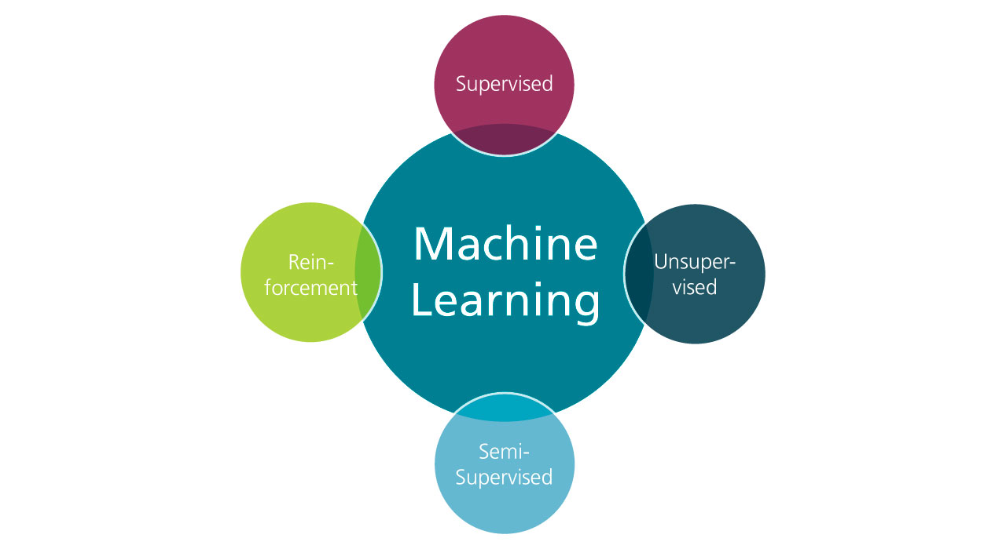**BACKGROUND**

**Figure 1**

Machine learning

Machine learning [1] plays a significant role in prediction, especially in gold price prediction and across various domains, from finance to healthcare to weather forecasting. It leverages algorithms and statistical models to analyze past data, identify patterns, and make predictions or decisions without explicit programming. Here are some key aspects of machine learning in prediction:

Predictive Analytics: Machine learning algorithms are extensively used in predictive analytics to forecast future outcomes based on historical data. For example, in finance, machine learning models can predict stock prices or detect fraudulent transactions. In healthcare, they can predict patient outcomes or identify potential diseases based on symptoms and medical history.

Pattern Recognition: Machine learning excels at recognizing patterns and trends in data that may not be immediately apparent to humans. By analyzing large datasets, machine learning models can uncover hidden correlations and make predictions based on these patterns. For instance, in marketing, machine learning algorithms can predict customer behavior based on past purchases and browsing history.

Regression and Classification: Machine learning prediction tasks often involve regression, where the goal is to predict a continuous value, or classification, where the goal is to assign an input to one of several categories. Regression algorithms can predict outcomes such as house prices or sales forecasts, while classification algorithms can predict whether an email is spam or legitimate.

Time Series Forecasting: Machine learning techniques are widely used for time series forecasting, where the goal is to predict future values based on past observations.

Time series forecasting is crucial in various fields such as finance, energy, and meteorology. For example, machine learning models can predict stock prices, energy demand, or weather patterns based on historical data.

Model Evaluation and Optimization: In machine learning prediction tasks, it's essential to evaluate the performance of models and optimize them for better accuracy and generalization. Techniques such as cross-validation, hyperparameter tuning, and ensemble methods are used to improve model performance and prevent overfitting.

Predictive Maintenance: Machine learning is increasingly used for predictive maintenance in industries such as manufacturing and transportation. By analyzing sensor data from equipment and machinery, machine learning models can predict potential failures before they occur, allowing for proactive maintenance and minimizing downtime.

Risk Assessment and Decision Making: Machine learning models are employed for risk assessment and decision making in various domains, including insurance, credit scoring, and healthcare. These models can assess the likelihood of an event occurring (e.g., defaulting on a loan) and help decision-makers make informed choices based on the predicted outcomes.

In summary, machine learning plays a crucial role in prediction by leveraging data-driven approaches to forecast future outcomes, identify patterns, and make informed decisions across diverse domains.

Machine learning has numerous applications in various fields, including healthcare, finance, transportation, and many others.

Some examples of machine learning applications include image and speech recognition, natural language processing, recommendation systems, fraud detection, and autonomous vehicles.

In order to implement machine learning algorithms, data scientists and machine learning engineers use programming languages such as

#### Python[2].

The success of machine learning algorithms depends on several factors, including the quality and quantity of the data used to train the algorithm, the choice of algorithm and its parameters, and the pre-processing and feature engineering techniques used to prepare the data. Machine learning models can also suffer from bias, overfitting, and generalization issues, which require careful evaluation and validation.

In conclusion, machine learning is a powerful tool for automating decision-making processes and extracting insights from complex data. The field continues to evolve rapidly, driven by advances in data availability, computational power, and algorithmic innovation. With the right data and algorithms, machine learning has the potential to revolutionize many aspects of our lives, from healthcare and education to transportation and entertainment.

Machine learning techniques can be broadly classified into three categories: supervised learning, unsupervised learning, and reinforcement learning.

### FigureA diagram of a learning process Description automatically generated 2

### Supervised Learning

Supervised learning [3] is a type of machine learning where the computer is trained on a labelled dataset, meaning that each data point in the dataset is associated with a known label or output variable.

The goal of supervised learning is to learn a mapping between the input features and the output labels so that the algorithm can accurately predict the output labels for new, unseen data.

In supervised learning, the training dataset is typically split into two subsets: a training set and a validation set.

The training set is used to train the algorithm, while the validation set is used to evaluate the performance of the algorithm and tune its parameters.

One of the advantages of supervised learning is that it can be used for a wide range of tasks, including regression[4], classification[5], and even time series prediction. For example, supervised learning can be used to predict stock prices, classify images, and even diagnose diseases based on medical data.

Predicting gold prices using supervised learning involves using historical data on gold prices and other relevant factors to train a machine learning model. Supervised learning algorithms learn from labeled data, where the input features (independent variables) are used to predict a target variable (dependent variable). Here's how gold price prediction can be approached using supervised learning:

Data Collection: The first step is to gather historical data on gold prices along with other relevant features that might influence gold prices. These features could include factors such as economic indicators (e.g., inflation rate, GDP growth), geopolitical events, currency exchange rates, stock market performance, and commodity prices.

Data Preprocessing: Once the data is collected, it needs to be preprocessed to ensure it's in a suitable format for training the machine learning model. This may involve handling missing values, scaling numerical features, encoding categorical variables, and splitting the data into training and testing sets.

Feature Selection and Engineering: Feature selection involves choosing the most relevant features that have the most significant impact on gold prices. Feature engineering may also be performed to create new features that could potentially improve the model's performance.

For example, lagged values of gold prices or moving averages could be created as additional features.

Model Selection: Several supervised learning algorithms can be used for gold price prediction, including linear regression, decision trees, random forests, support vector machines (SVM), and neural networks.

The choice of algorithm depends on factors such as the complexity of the relationship between features and target variable, the amount of data available, and computational resources.

Model Training: The selected machine learning algorithm is trained on the historical data, where the input features are used to predict gold prices. During training, the algorithm adjusts its parameters to minimize the difference between the predicted and actual gold prices.

Model Evaluation: Once the model is trained, it needs to be evaluated using a separate test dataset to assess its performance. Common evaluation metrics for regression tasks include mean absolute error (MAE), mean squared error (MSE), and root mean squared error (RMSE). These metrics quantify how close the predicted gold prices are to the actual prices.

Model Tuning and Optimization: The model may be fine-tuned by adjusting hyperparameters to improve its performance.

Techniques such as cross-validation and grid search can be used to find the optimal combination of hyperparameters.

Prediction and Monitoring: Once the model is trained and evaluated, it can be used to make predictions on new, unseen data. It's essential to continuously monitor the model's performance over time and retrain it periodically with updated data to ensure its accuracy and relevance.

By following these steps, supervised learning can be employed to predict gold prices using historical data and other relevant factors, enabling investors,

traders, and financial institutions to make informed decisions in the gold market.

However, there are some limitations to supervised learning. One of the main challenges is obtaining labelled data, which can be time-consuming and expensive. Additionally, supervised learning is not well suited for problems where the output variable is continuous and has many possible values.

To overcome these limitations, researchers have developed a variety of techniques and algorithms, such as semi-supervised learning [6], transfer learning, which can help improve the performance of supervised learning on a wide range of tasks.

Classification and regression are two common types of supervised learning problems in machine learning.

.

**Figure 3**

Regression is a type of supervised learning in machine learning that deals with predicting a continuous output variable based on one or more input variables.

The goal of regression is to establish a mathematical relationship between the input variables and the output variable so that it can be used to make predictions for new input values.

It is commonly used in many applications, such as finance, healthcare, and marketing, where there is a need to predict a numerical value or a set of numerical values.

Examples of regression problems include predicting housing prices based on location and square footage, predicting stock prices based on historical data, and predicting weather patterns based on various atmospheric conditions.

#### Linear Regression

**Figure 4**

Linear regression [7] is a commonly used regression algorithm that assumes a linear relationship between the input variables and the output variables.

It aims to find the best-fit line that minimizes the sum of the squared differences between the predicted values and the actual values.

Linear regression can be used for both simple and multiple regressions where there is more than one input variable.

The equation for a linear regression model is typically of the form y = mx + b, where y is the output variable, x is the input variable, m is the slope of the line, and b is the y-intercept.

Linear regression can be used to model a wide variety of relationships between the input and output variables, and it is often used in fields such as economics, finance, and engineering.

For example, linear regression can be used to predict housing prices based on factors such as the number of bedrooms, the size of the house, and the location.

XGBoost (Extreme Gradient Boosting):

* XGBoost is an advanced supervised learning algorithm based on gradient boosting techniques.
* It is widely used for both regression and classification tasks and is known for its high performance and scalability.
* XGBoost builds an ensemble of weak learners (decision trees) sequentially, with each tree correcting the errors made by the previous ones.
* It employs gradient descent optimization to minimize a predefined loss function, such as mean squared error for regression tasks.
* XGBoost is an advanced supervised learning algorithm based on gradient boosting techniques, designed for both regression and classification tasks.
* It builds an ensemble of weak learners (decision trees) sequentially, with each tree correcting the errors made by the previous ones.
* It introduces several regularization techniques to prevent overfitting, such as shrinkage (learning rate), maximum tree depth, and subsampling of training instances and features.
* XGBoost is known for its high performance, scalability, and effectiveness in handling complex datasets, making it a popular choice in machine learning competitions and industry applications.

Random Forest Regression:

* Random forest is another ensemble learning method used for regression and classification tasks.
* It builds multiple decision trees during training and aggregates their predictions to make the final prediction.
* Each decision tree in the random forest is trained on a random subset of the training data (bootstrap samples) and a random subset of the input features.
* The final prediction is typically the average (for regression) or the mode (for classification) of the predictions made by individual trees.
* During training, it builds a forest of decision trees by randomly selecting subsets of the training data (bootstrap samples) and a random subset of the input features for each tree.
* Each decision tree is trained independently, making predictions based on the majority vote (for classification) or averaging (for regression) of the predictions made by individual trees.
* Random forest introduces randomness in the tree-building process, which helps reduce overfitting and improves generalization performance.
* It is robust to outliers and noise in the data and can handle high-dimensional feature spaces efficiently, making it suitable for a wide range of regression tasks, including those with nonlinear relationships.

Each algorithm has its own strengths and weaknesses, and the choice of algorithm depends on the problem at hand and the properties of the data.

### Transfer learning

**Transfer learning [8]** is a machine learning technique that involves leveraging knowledge learned from one task to improve the performance of another related task. The idea behind transfer learning is that if a model has learned to solve one problem well, it can use that knowledge to solve a related or even unrelated problem more efficiently and with less training data.

**In traditional deep learning**, models are trained from scratch on large datasets, which can be time-consuming and computationally expensive.

**Transfer learning** enables the transfer of knowledge from pre-trained models to new models with similar data, saving time and resources. There are two main types of transfer learning: **domain adaptation** and **fine-tuning.**



**Transfer Learning**



**domain adaptation**



**fine**

**-**

**tuning**

#### Domain adaptation

**Domain adaptation [9]** involves adapting a pre-trained model to a new, but related, dataset. For example, if a model was trained to classify images of cats and dogs, it could be adapted to classify images of lions and tigers. This can be done by freezing the pre-trained layers of the model and adding new layers specific to the new dataset.

#### Fine-tuning

**Fine-tuning [10]** involves taking a pre-trained model and training it on a new dataset with the same or similar tasks.

For example, a pre-trained model for image classification can be fine-tuned on a new dataset of images to improve its performance on the new task.

This can be done by adjusting the weights of the pre-trained layers and training the entire model on the new dataset.

**Transfer learning** has several **advantages** over training models from scratch.

**First**, pre-trained models are often trained on large datasets, which allows them to learn general features that can be applied to a wide range of tasks.

This means that transfer learning can be used to solve problems with smaller datasets, which would not be possible with traditional deep learning.

**Second**, transfer learning can reduce the amount of training data required to achieve high performance on a new task.

This is because pretrained models have already learned useful features that can be used to solve related tasks, reducing the amount of data needed to train a new model.

**Third**, transfer learning can improve the speed of model training. Pretrained models can be used as a starting point for model training, which can reduce the number of training iterations required to achieve good performance on a new task.

In **conclusion**, transfer learning is a powerful technique that can improve the performance of machine learning models and reduce the amount of time and resources required for training.

It has been successfully applied in a wide range of applications, and its potential for future research and development is immense.

As models become more complex and datasets become larger, transfer learning will continue to play an increasingly important role in machine learning and artificial intelligence.

**Types of Transfer Learning:**

Feature Extraction: In this approach, the pre-trained model is used as a fixed feature extractor.

The learned representations from the earlier layers of the model are extracted and fed into a new model, which is then trained on the target task.

Fine-Tuning: This approach involves fine-tuning the entire pre-trained model on the target task.

The pre-trained model's weights are updated during training on the new dataset, often with a lower learning rate to prevent drastic changes to the learned representations.

Pre-trained Models: Transfer learning typically involves using pre-trained models that are trained on large-scale datasets like ImageNet (for computer vision tasks) or large text corpora (for natural language processing tasks).

These pre-trained models, such as VGG, ResNet, BERT, GPT, etc., serve as a starting point for transfer learning.

Transfer Learning in Computer Vision:

In computer vision, transfer learning is commonly used for tasks such as object detection, image classification, and image segmentation.

For example, a pre-trained convolutional neural network (CNN) [21] like VGG or ResNet, which is trained on a large dataset like ImageNet for image classification, can be fine-tuned on a smaller dataset for a specific classification task.

Transfer Learning in Natural Language Processing (NLP):

In NLP, transfer learning is prevalent in tasks such as text classification, sentiment analysis, and named entity recognition.

Pre-trained language models like BERT (Bidirectional Encoder Representations from Transformers) or GPT (Generative Pre-trained Transformer) are often fine-tuned on task-specific datasets to improve performance.

Benefits of Transfer Learning:

Reduces the need for large amounts of labeled data for training, especially useful when labeled data is scarce or expensive to obtain.

Speeds up the training process since the pre-trained model has already learned useful features, allowing faster convergence on the target task.

Improves generalization and performance on the target task, as the pre-trained model has learned representations from diverse datasets.

Challenges and Considerations:

Domain mismatch: If the source and target domains are significantly different, transfer learning may not be effective.

Overfitting: Fine-tuning a pre-trained model on a small dataset may lead to overfitting.

Regularization techniques such as dropout and weight decay can help mitigate this issue.

Task selection: Choosing an appropriate pre-trained model and deciding whether to perform feature extraction or fine-tuning depends on factors like dataset size, similarity between source and target tasks, and computational resources.

Overall, transfer learning is a powerful technique that allows leveraging knowledge from pre-trained models to improve performance on target tasks, making it a valuable tool in machine learning and deep learning applications.

In prediction tasks, transfer learning can offer several benefits:

Improved Accuracy: By leveraging pre-trained models that have been trained on large datasets for similar tasks, you can benefit from the learned representations, which may lead to improved accuracy in your predictions. These representations capture useful patterns and features that generalize well to new data.

Reduced Data Requirements: Transfer learning allows you to train predictive models with less labeled data. Instead of starting from scratch and training a model from the ground up, you can fine-tune a pre-trained model on your specific dataset. This is particularly advantageous when labeled data is limited or expensive to obtain.

Faster Training: Since the pre-trained model has already learned useful features, the training process can be significantly faster compared to training a model from scratch. This is especially beneficial when dealing with large datasets or complex models, as transfer learning enables you to converge to a good solution more quickly.

Resource Efficiency: Transfer learning can save computational resources by reusing pre-trained models and their learned representations. Instead of training a new model from scratch, you can adapt an existing model to your prediction task, thereby reducing the need for extensive computing resources and time.

Domain Adaptation: Transfer learning can help in adapting models trained on one domain to perform well in a related but slightly different domain. For example, if you have a pre-trained model for predicting customer behavior in one industry, you can transfer the knowledge to a similar industry with minor adjustments, thereby speeding up the deployment of predictive models in new domains.

Incremental Learning: Transfer learning allows for incremental learning, where you can continuously fine-tune and update your predictive models as new data becomes available. This enables your models to adapt to changing conditions, evolving trends, and newly emerging patterns over time, ensuring that your predictions remain accurate and up-to-date.

Overall, transfer learning can be a valuable technique in prediction tasks, offering improved accuracy, reduced data requirements, faster training, resource efficiency, domain adaptation, and support for incremental learning. By leveraging pre-trained models and their learned representations, you can achieve more accurate and efficient predictions across various domains and applications.

### Pretraining model

**Pre-training models [11]** is a technique used in machine learning that involves training a model on a large dataset to learn features that can be used for a wide range of tasks.

**Pre-training models** have become increasingly popular in recent years due to their ability to improve the performance of machine learning models, reduce the amount of training data required, and save time and resources.

A popular pre-training model is **the convolutional neural network (CNN)**, which is a type of neural network that is designed for image recognition and classification. CNNs are pre-trained on large datasets such as **ImageNet [12]**, which contains millions of images, to learn features such as edges, corners, and textures that can be used for a wide range of image-related tasks.

Pre-training models can also be used for transfer learning, where a pretrained model is fine-tuned on a new, smaller dataset to improve its performance on a specific task. This approach is particularly useful when the new dataset is small or when the task is similar to the one that the pre-trained model was originally trained on. Transfer learning with pre-trained models can significantly reduce the amount of training data required and improve the accuracy of the final model.

One of the main **advantages** of pre-training models is that they can learn useful features from large datasets that can be transferred to other tasks.

This is particularly important in machine learning applications, where collecting and labelling large datasets can be time-consuming and expensive.

Pre-training models can also improve their performance on tasks that have limited amounts of labelled data, which is a common problem in many real-world applications.

Another advantage of pre-training models is that they can reduce the amount of time and resources required to train a model from scratch. Pre-training models can be used as a starting point for training a new model, which can significantly reduce the number of training iterations required. This is particularly useful in applications where training models can be computationally expensive, such as natural language processing and computer vision.

However, pre-training models also have some limitations. For example, pre-training models are only effective when the pre-training task is related to the target task. If the pre-training task is not related, then the pre-trained model may not learn relevant features for the target task. Additionally, pre-training models require large amounts of data, which may not be available in some applications.

In **conclusion**, pre-training models are a powerful technique for improving the performance of machine learning models, **reducing the amount of training data required**, and **saving time** and resources.

Pre-training models come in many forms, such as **autoencoders**, **generative models**, and **convolutional neural networks**, and they can be used for a wide range of applications, including **natural language processing**, **image recognition**, and **speech recognition**.

The training process of a pretrained model depends on the specific architecture and objectives of the model. However, I'll provide a general overview of the training process for pretrained models in deep learning:

**Data Collection and Preprocessing**:

* The training data for a pretrained model is typically collected from large-scale datasets relevant to the target task or domain.
* The data is preprocessed to ensure consistency, quality, and suitability for the training objectives. This may involve tasks such as resizing images, normalizing pixel values, tokenizing text, and handling missing values.

**Model Architecture**:

* The architecture of the pretrained model is designed based on the specific task and domain requirements. Common architectures include convolutional neural networks (CNNs) for computer vision tasks and transformer-based architectures for natural language processing tasks.
* The model architecture defines the structure of the neural network, including the number of layers, types of layers.
* (e.g., convolutional layers, pooling layers, recurrent layers), and connectivity patterns.  
  **Initialization**:
* Before training, the parameters (weights and biases) of the pretrained model are initialized either randomly or using pre-trained weights from a model trained on a large dataset (e.g., ImageNet for computer vision tasks, Wikipedia for language tasks).
* Pre-initialized weights help accelerate convergence during training and improve the model's ability to capture meaningful features from the input data.

**Objective Function**:

* The objective function, also known as the loss function, quantifies the difference between the model's predictions and the ground truth labels or targets.

The choice of objective function depends on the specific task and the desired behavior of the model. Common loss functions include mean squared error (MSE) for regression tasks and categorical cross-entropy for classification tasks.

**Training Algorithm**:

The training algorithm, such as stochastic gradient descent (SGD), Adam, or RMSprop, is used to update the model parameters iteratively based on the gradients of the objective function with respect to the parameters.

During each training iteration (epoch), the model is presented with batches of training examples, and the gradients are computed using backpropagation through the neural network.

**Validation and Evaluation**:

Throughout the training process, the model's performance is monitored on a separate validation dataset to assess its generalization ability and prevent overfitting.

* Evaluation metrics such as accuracy, precision, recall, and F1-score are computed on the validation set to measure the model's performance on the target task.

**Hyperparameter Tuning**:

* Hyperparameters such as learning rate, batch size, regularization strength, and network architecture are tuned to optimize the model's performance and convergence speed.
* Techniques like grid search, random search, or Bayesian optimization may be employed to search the hyperparameter space efficiently.

Overall, the training process of a pretrained model involves iteratively updating the model's parameters to minimize a predefined objective function, leveraging large-scale datasets and pre-initialized weights to learn meaningful representations of the input data.

### Overfitting and Underfitting

**What is Overfitting?**

**Overfitting [13]** occurs when a machine learning model learns the training data too well, to the extent that it starts to memorize the noise and random fluctuations in the data. As a result, the model performs exceptionally well on the training data but fails to generalize to new, unseen data. Overfitting often happens when the model is too complex or when there is insufficient data to capture the underlying patterns.

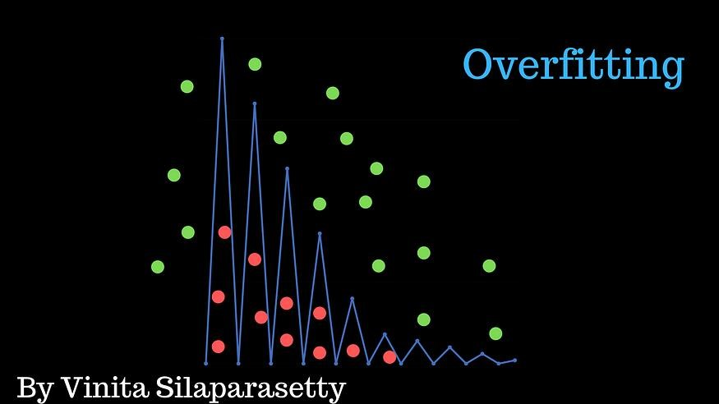

**Figure 5**

**What is Underfitting?**

**Underfitting [14]** happens when a machine learning model is too simplistic and fails to capture the underlying patterns in the training data. The model's performance is poor not only on the training data but also on new, unseen data. Underfitting can occur when the model is too simple or when the training data is insufficient to capture the complexity of the problem.

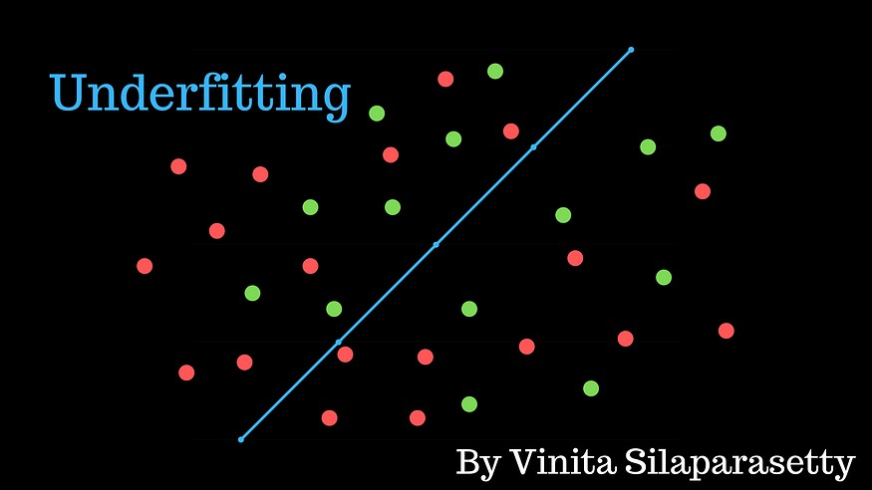

**Figure 6**

**How Do You Solve the Problem of Overfitting and Underfitting?**

Overfitting and underfitting are common challenges in machine learning that occur when a model fails to generalize well to unseen data. Overfitting refers to a situation where the model performs well on the training data but poorly on new, unseen data, while underfitting occurs when the model is too simple to capture the underlying patterns in the data, resulting in poor performance on both the training and test data. Here are several strategies to address these problems:

* **Cross-validation:** splitting the available data into multiple subsets to train and evaluate the model. This helps to estimate the model's performance on unseen data.
* **Regularization:** Adding a penalty term to the model's loss function to discourage overly complex models Regularization techniques, such as L1 or L2 regularization, constrain the model's parameters, preventing them from becoming too large.
* **Early stopping:** monitoring the model's performance during training and

stopping the training process early when the model's performance on

validation set starts to degrade. This helps prevent overfitting by finding the optimal point where the model generalizes well.

* **Pruning:** Removing unnecessary features or reducing the complexity of the model by eliminating irrelevant or redundant parameters. This helps prevent overfitting by simplifying the model.
* **Dropout:** a regularization technique commonly used in neural networks. During training, randomly selected neurons are temporarily dropped out, meaning their outputs are ignored. This helps prevent the network from relying too much on specific neurons and encourages the learning of more robust features.

**Handling Underfitting:**

* **Increasing model complexity:** if the model is too simple, increasing its complexity by adding more layers, increasing the number of parameters, or using more sophisticated algorithms can help capture the underlying patterns in the data.
* **Feature engineering:** analyzing and transforming the input features to make them more informative and suitable for the model. This can involve selecting relevant features, creating new features, or applying transformations to existing ones.
* **Collecting more data:** Insufficient data can contribute to underfitting. Gathering more diverse and representative data can provide the model with more information to learn from and improve.
* **Train-Validation-Test Split:** Splitting the data into separate training, validation, and test sets allows for independent evaluation of the model's performance. The training set is used to train the model, the validation set is used to tune hyperparameters and monitor performance, and the test set is used to evaluate the final model's generalization performance.
* **Feature Selection and Dimensionality Reduction:** Selecting only the most relevant features or reducing the dimensionality of the input data can help prevent overfitting by focusing on the most informative aspects of the data.
* Techniques such as principal component analysis (PCA) and feature importance analysis can identify the most discriminative features for the task at hand.
* **Ensemble Methods:** Ensemble methods, such as bagging, boosting, and stacking, combine multiple models to improve generalization performance and reduce overfitting.
* By aggregating predictions from multiple models trained on different subsets of the data or using different algorithms, ensemble methods can reduce variance and improve the overall performance of the model.
* **Data Augmentation:** Data augmentation techniques, such as rotation, translation, scaling, and flipping, artificially increase the size of the training data by applying transformations to the existing samples.

Data augmentation helps expose the model to a wider variety of data patterns and reduces overfitting by providing more diverse training examples.

* **Model Complexity Adjustment:** Adjusting the complexity of the model architecture, such as reducing the number of layers or nodes in a neural
* network, can help prevent overfitting by constraining the model's capacity to memorize the training data.
* Simplifying the model architecture reduces the risk of overfitting and encourages the model to learn more generalizable patterns from the data.

By employing these strategies, machine learning practitioners can effectively mitigate the risks of overfitting and underfitting, leading to more robust and generalizable models. It's essential to experiment with different approaches and monitor the model's performance carefully to strike the right balance between bias and variance.

### Kerase Functions

"Keras Functions," referring to functions within the Keras deep learning framework.

Model Building Functions:

Sequential: This function allows you to create a sequential model, which is a linear stack of layers. It's suitable for most simple deep learning tasks where the data flows sequentially through the layers.

Model: This function is used to create more complex models with multiple input and output layers. It allows for greater flexibility in defining the architecture of your neural network.

Layer Function:

Keras provides a wide range of layer functions to construct different types of neural network layers, including:

Dense: A fully connected layer where each neuron is connected to every neuron in the preceding layer.

Conv2D, Conv1D: Convolutional layers used in image and sequence processing, respectively.

MaxPooling2D, MaxPooling1D: Pooling layers used for downsampling feature maps.

LSTM, GRU: Recurrent layers for processing sequential data, such as time series or natural language.

Dropout: A regularization layer that randomly sets a fraction of input units to zero during training to prevent overfitting.

Activation Functions:

Keras includes various activation functions that introduce non-linearity into the network, including:

relu: Rectified Linear Unit, which is commonly used in hidden layers due to its simplicity and effectiveness.

sigmoid: S-shaped activation function used for binary classification tasks.

softmax: Activation function used in the output layer for multi-class classification tasks to obtain probability distributions over classes.

Loss Functions:

Keras provides a variety of loss functions for different types of tasks, such as:

mean_squared_error: Used for regression tasks to measure the mean squared difference between predicted and true values.

binary_crossentropy: Commonly used for binary classification tasks.

categorical_crossentropy: Used for multi-class classification tasks with one-hot encoded labels.

Optimizer Functions:

Keras supports various optimizers for training neural networks, including:

**Chapter 3**

# 

**Literature Review**

**CHAPTER 3**

**LITERATURE REVIEW**

|  |  |  |  |  |
| --- | --- | --- | --- | --- |
| No. | Year | Algorithm | Accuracy | Dataset |
| Paper 1 | 2022 | Random Forest  Regression | 98% | Date: Monthly price data for the period of January 2008 to May 2018 |
| Paper 2 | 2022 | Random Forest  Regression | 98.87% | Gold price Data |
| Paper 3 | 2021 | XG-Boost | 97% | gold price with the XG-Boost algorithm and SHAP |
| Paper 5 | 2020 | Random Forest | 98% | monthly gold prices from March 1988 to December 2016 |
| Paper 6 | 2019 | Linear Regression | 98.76% | Data collected from (http:/www.etf.com/GLD) |

**Paper 1**

**Gold Price Prediction [15]**

Publication Year: 2022

**Abstract**

Gold is often used by investors as a barrier against inflation or adverse economic times. As a result, it is critical for investors to be able to accurately estimate gold prices. This article is based on a study of gold price prediction by relationship between gold price and selected factors influencing it , namely date, stock value, current gold price ,united state oil price, current silver price, currency medium(EUR/USD) using Collab by random forest regression algorithm. Comparing and Analyze R squared error graph and mean_absolute_error, and with linear regression algorithm. Monthly price data for the period January 2008 to May 2018 was used for the study. Two machine learning algorithms random forest regression and linear regression were used in analyzing these data. Random forest regression, on the other hand, has been found to have greater overall prediction accuracy.

**Dataset**

Date: Monthly price data for the period of January 2008 to May 2018.

**Algorithm:**

Random Forest regression

Accuracy: 98%

**Paper 2**

**Ensemble Regression-Based Gold Price (XAU/USD) Prediction [16]**

Publication Year: 2022

**Abstract**

This paragraph discusses the challenges associated with predicting the value of commodities such as cryptocurrency, stocks, silver, and gold. The author presents a model designed to forecast the value of 1 ounce of gold in dollars using regression ensemble-based approaches. The study is claimed to be the first of its kind in combining regression models to predict the XAU/USD index. The dataset used in the study was collected between July 2019 and July 2020 from global financial websites, and various regression and ensemble-based regression models were applied, including linear regression, polynomial regression, decision tree regression, random forest regression, support vector regression, voting regressor, and stacking regressor. The results indicate that the stacking regression combination model produced significant outcomes, with a Mean Absolute Percentage Error (MAPE) of 2.2036 for forecasting the XAU/USD index price.

**Dataset:**

Gold Price Data

**Algorithm:**

Random Forest regression

Accuracy: 98.87%

**Paper 3**

**Forecasting gold prices with the XG-Boost algorithm and SHAP interaction values [17]**

Publication Year: 24 June 2021

**Abstract**

Financial institutions, investors, mining companies and related firms need an effective accurate forecasting model to examine gold price fluctuations in order to make correct decisions. This paper proposes an innovative approach to accurately forecast gold price movements and to interpret predictions. First, it compares six machine learning models. These models include two very recent methods: the Extreme Gradient Boosting (XG-Boost) and Cat-Boost. The empirical findings indicate the superiority of XG-Boost over other advanced machine learning models. Second, it proposes Shapley additive explanations (SHAP) in order to help policy makers to interpret the predictions of complex machine learning models and to examine the importance of various features that affect gold prices. Our results illustrate that the utilization of XG-Boost along with SHAP approach could pro vide a significant boost in increasing the gold price forecasting performance.

**Dataset**

gold price with the XG-Boost algorithm and SHAP interaction values

**Algorithm:**

XGBOOST

Accuracy: 97%

**Paper 4**

**Assessing the Performance of Machine Learning Methods in Forecasting Gold Prices [18]**

Publication Year: January 2020

**Abstract**

Commodities prices are important to the mineral investment decision and have a high impact on the financial performance of mineral resource companies. Therefore, understanding the short-term future mineral price movement is key for short and medium term mine planning. In this article, supervised machine learning methods namely decision trees, random forest and support vector regression were used to forecast monthly gold prices from March 1988 to December 2016. The results were analyzed and compared to each other using forecasting accuracy and root mean squared error (RMSE), mean absolute error (MAE), and mean squared error (MSE). Random Forest emerged as a best of all the three methods to forecast monthly gold prices.

**Dataset**

monthly gold prices from March 1988 to December 2016

**Algorithm**

Random Forest regression

Accuracy: 98%

**Paper 5**

**Gold Price Prediction using Ensemble based Machine Learning Techniques [19]**

Publication Year: 2019

**Abstract**

This article is based on a study conducted to understand the relationship between gold price and selected factors influencing it, namely stock market, crude oil price, rupee dollar exchange rate, inflation and interest rate. Monthly price data for the period January 2000 to December 2018 was used for the study. The data was further split into two periods, period I from January 2000 to October 2011 during which the gold price exhibits a raising trend and period II from November 2011 to December 2018 where the gold price is showing a horizontal trend. Three machine learning algorithms,

linear regression, random forest regression and gradient boosting regression were used in analyzing these data. It is found that the correlation between the variables is strong during the period I and weak during period II. While these models show good fit with data during period I, the fitness is not good during the period II. While random forest regression is found to have better prediction accuracy

for the entire period, gradient boosting regression is found to give better accuracy for the two periods taken separately.

**Dataset**

gold price

**Algorithm**

Random Forest regression

Accuracy: 98.9%

**Paper 6**

**Gold Price Prediction using Machine Learning [20]**

Publication Year: 06 | June – 2022

**Abstract**

the tradition of holding gold as a valuable asset has persisted throughout centuries. In many Asian countries, gold is not just a financial commodity but also a symbol of wealth, prosperity, and cultural significance. It plays a vital role in traditional ceremonies, gift-giving, and social customs.

In the modern era, the significance of gold has evolved beyond just being a precious metal. It is now a strategic asset held by central banks to safeguard against economic uncertainties, ensure financial stability, and maintain trust in the financial system. The value of gold often reflects the economic stability and monetary policies of a country, making it a key indicator of financial health.

Furthermore, the popularity of gold as an investment option has grown globally. Both institutional investors and individual stakeholders consider gold as a safe haven asset during times of market volatility or economic crisis. Its price is influenced by various factors such as interest rates, inflation, geopolitical events, and currency movements.

With the advancements in machine learning techniques, the analysis and prediction of gold rates have become more sophisticated and data-driven. By leveraging historical data and market variables, researchers and analysts can gain insights into the future trends and fluctuations in the price of gold, aiding decision-making processes for investors and financial institutions.**Dataset**

Data collected from (http:/www.etf.com/GLD) from January 2005 to August

**Algorithm**

Linear Regression

Accuracy: 98.76%

# CHAPTER 4

# IMPLEMENTATION

**Data Collection**

Predicting gold prices accurately has long been a covered skill in the financial world.

However, achieving this feat requires a solid foundation – a comprehensive dataset that captures the complex interplay of factors influencing gold's value.

This project's journey begins with meticulous data collection, the very cornerstone upon which our Machine Learning (ML) model will be built.

Our primary focus will be on gathering historical gold price data.

This will involve acquiring data points spanning a significant timeframe, capturing the long-term trends and short-term fluctuations that define gold's price history.

Here, we will find more ways to collect data sources, such as Kaggle and sources from research papers. For example:

From paper “**Ensemble Regression-Based Gold Price (XAU/USD) Prediction**”[010]

In this work, regression ensemble-based model is proposed to estimate the value of 1 ounce of gold in dollars (XAU/USD index). To demonstrate the effect of proposed regression ensemble-based model, seven different regression models namely, linear regression, polynomial regression, decision tree regression, random forest regression, support vector regression, voting regressor, stacking regressor are evaluated. For this purpose, the dataset is collected between July 2019 and July 2020 from financial websites, and enhanced with various indicators such as simple moving average (SMA) for 20, 50, and 100 days, opening, closing, highest and lowest dollar index (DXY) prices, 14-day relative strength index (RSI), the upper, middle and lower values of the Bollinger band (BB), and prepared for model construction.

From paper “**Forecasting gold price with the XGBoost algorithm and SHAP interaction values**”[011]

In this paper, we investigate the effect of several explanatory variables on gold price, which is given in US dollars. The data covers the period from January 1986 to December 2019, including 408 monthly observations. This study has been divided into training (80%) and test (20%) samples in order to compare the performances of different machine learning models. We randomly partition the dataset by selecting 80% of the data as the training data set and the remaining 20% as the testing set. show that that the best results are obtained if we use 20–30% of the data for testing, and the remaining 70–80% of the data for training.

From paper “Gold Price Prediction”[09]

Monthly price data for the period January 2008 to May 2018 was used for the study.

From paper “Assessing the Performance of Machine Learning Methods in Forecasting Gold Prices”[012]

The data used for this research ranged from March 1988 to December 2016.

From paper “Gold Price Prediction using Ensemble based Machine Learning Techniques”[013]

Monthly price data for the period January 2000 to December 2018 was used for the study.

The data was further split into two periods, period I from January 2000 to October 2011 during which the gold price exhibits a raising trend and period II from November 2011 to December 2018 where the gold price is showing a horizontal trend.

# From paper “Gold Price Prediction using Machine Learning”[014]

Data for this study are collected from source (http:/www.etf.com/GLD) from January 2005 through August 2020.

GLD is the largest ETF with direct investments in actual gold.

Beyond historical gold prices, we aim to capture a broader picture by collecting data on potentially influential factors.

Here are some of the additional data points we'll target.

Economic Indicators: Stock market indices, interest rates, inflation data, and economic growth figures can paint a picture of the overall financial climate, which can have a significant impact on gold's demand and price.

Currency Fluctuations: Changes in the exchange rate between major currencies, particularly the US Dollar, can affect the relative attractiveness of gold as an investment. Currency exchange data will be crucial for understanding these dynamics.

The process of data collection is more than just gathering information. It will involve meticulous cleaning and pre-processing steps.

This ensures the data is consistent, free of errors, and formatted appropriately for our ML model.

Techniques like handling missing values, identifying outliers, and feature scaling will all be employed to create a high-quality dataset.

By meticulously constructing a comprehensive and well-refined dataset, we lay the groundwork for a robust ML model.

This robust foundation will be instrumental in unlocking the secrets behind gold price movements, paving the way for accurate predictions in the future.

Stay tuned as we delve deeper into the exciting world of data collection and pre-processing – the crucial first steps in our journey towards gold price prediction.

**Challenges of using Custom Dataset**

The Double-Edged Sword: Challenges of Using a Custom Dataset for Gold Price Prediction

While crafting a custom dataset offers immense control and potential for gold price prediction, it also presents a unique set of challenges.

Understanding these challenges is crucial for ensuring the success of our project.

Here are some of the key hurdles we'll need to navigate:

Data Availability: Acquiring comprehensive data, especially for historical periods or niche factors, can be difficult. Financial databases may require subscriptions, government websites might have limited data access, and collecting data on specific geopolitical events may necessitate manual scraping techniques.

Data Quality: The accuracy and consistency of data obtained from various sources can vary.

Inaccurate or inconsistent data can lead to misleading patterns and negatively impact the performance of our ML model.

Careful cleaning and validation steps will be essential to ensure data quality.

Data Bias: The sources we choose can introduce bias into the dataset.

For instance, focusing solely on data from developed economies might neglect trends relevant to emerging markets.

We'll need to be mindful of potential biases and strive for a balanced dataset encompassing diverse perspectives.

Data Completeness: Missing data points can be a significant obstacle.

While some techniques exist to handle missing values, extensive gaps in the data can limit the effectiveness of our ML model.

We'll need to explore strategies for imputing missing data or potentially excluding incomplete data points.

Data Size: While a comprehensive dataset is desirable, a very large dataset can pose computational challenges. Training our ML model on a massive dataset might require significant computing resources and could lead to overfitting.

Finding the right balance between comprehensiveness and manageability will be crucial.

These challenges highlight the importance of careful planning and execution during data collection.

Here are some strategies we'll employ to mitigate these risks:

Diversifying Data Sources: Utilizing data from a variety of credible sources, such as financial databases, government websites, and reputable news outlets, can help us achieve a completer and more balanced dataset.

Implementing Data Validation Techniques: Employing data cleaning techniques like identifying outliers, checking for inconsistencies, and verifying accuracy will ensure the quality of the data we use.

Exploring Data Augmentation Techniques: If missing data poses a significant challenge, we can explore data augmentation techniques like interpolation or synthetic data generation to fill the gaps responsibly.

Optimizing Data Size: We might need to employ data sampling techniques or dimensionality reduction methods to ensure the dataset remains manageable for our chosen ML algorithms while retaining its key characteristics.

By acknowledging and addressing these challenges, we can transform the data collection process from a hurdle into a strategic advantage.

A well-curated, high-quality dataset will empower our ML model to learn effectively and ultimately generate accurate gold price predictions.

Stay tuned as we explore strategies to overcome these challenges and build a robust foundation for our project.

**Data Preprocessing**

Refining the Raw Material: Data Preprocessing for Gold Price Prediction

We've meticulously gathered a custom dataset for gold price prediction, but the journey doesn't end there.

Just like a sculptor transforms raw materials into a masterpiece, we need to preprocess our data to make it suitable for our Machine Learning (ML) model.

This preprocessing stage is crucial for ensuring the model can learn effectively and generate accurate predictions.

Imagine our dataset as a jumbled box of tools – some rusty, some broken, and some missing pieces.

Preprocessing helps us clean, organize, and standardize these tools so the ML model can use them optimally.

Here are some key steps involved in data preprocessing:

Handling Missing Values: Missing data points are a common challenge. We'll employ techniques like deletion (if minimal), mean/median imputation (filling in missing values with the average/median of existing data), or more sophisticated techniques like interpolation or synthetic data generation to address this issue.

Identifying and Addressing Outliers: Outliers – data points that deviate significantly from the norm – can skew our model's learning. We'll utilize techniques like z-scores or interquartile ranges to identify outliers, and then decide on appropriate strategies like removal, historization (capping outliers to a certain range), or transformation (converting outliers to values closer to the main distribution) to handle them.

By meticulously applying these preprocessing steps, we transform our raw dataset into a refined and standardized format.

This ensures all features are clean, consistent, and speak the same "language" to our ML model.

A well-preprocessed dataset empowers the model to identify meaningful relationships between features and gold prices, ultimately leading to more accurate predictions.

**The importance of the data**

The Unsung Hero: Why Data is the Cornerstone of Gold Price Prediction

In our quest to predict gold prices with the aid of Machine Learning (ML), data takes center stage.

It's the very foundation upon which our project is built, the fuel that powers our models, and the key to unlocking the mysteries of gold price movements.

Here's why data holds such immense importance:

Learning from Experience: ML algorithms are essentially sophisticated pattern recognition machines.

They learn from historical data, identifying correlations and relationships between various factors and gold prices.

The more comprehensive and accurate our data, the richer the pool of experience our models can draw from, leading to more accurate predictions.

Identifying Underlying Relationships: The true value of gold lies not just in its price, but in the complex interplay of economic, political, and social forces

that influence it. A well-curated dataset allows us to capture these intricate relationships.

By analyzing vast amounts of data, our models can uncover hidden patterns and connections that might be missed by traditional analysis methods.

Building a Robust Model: The robustness and accuracy of our ML model hinge on the quality of the data we feed it.

A dataset riddled with errors, inconsistencies, or biases can lead the model to learn misleading patterns and ultimately generate inaccurate predictions.

Conversely, a clean, well-preprocessed dataset empowers the model to learn effectively and make informed predictions.

Adapting to a Dynamic Market: The gold market is a living, breathing entity, constantly evolving in response to global events and economic shifts.

Our data needs to reflect this dynamism.

By incorporating data on relevant factors like economic indicators, geopolitical events, and currency fluctuations, we ensure our model can adapt to changing market conditions and maintain its predictive power.

Guiding Investment Decisions: Ultimately, the goal of this project is to provide valuable insights for investors and financial institutions. High-quality data, meticulously analyzed by our ML models, can offer data-driven predictions that empower users to make informed decisions about buying, selling, or holding gold within their portfolios.

Data is more than just numbers; it's a powerful tool that allows us to understand the world around us.

In the context of gold price prediction, data becomes the Rosetta Stone, unlocking the hidden language of the gold market.

By harnessing the power of data and leveraging it through sophisticated ML models, we strive to unveil the secrets behind gold price movements and empower informed decision-making in this ever-evolving landscape.

**process in data files**

Wrangling the Data: Processing Steps Within Data Files for Gold Price Prediction

Our journey towards gold price prediction has taken us through the crucial stages of data collection and preprocessing.

Now, we delve into the world of data files and explore the specific processes that occur within them to prepare the data for our Machine Learning (ML) models.

Imagine a data file as a treasure chest – it holds the raw materials we meticulously gathered. But to unlock its true potential, we need to perform specific actions within the file itself. Here's a breakdown of some key processing steps that occur within data files for gold price prediction:

Data Cleaning: Techniques like removing duplicate entries, correcting inconsistencies (e.g., typos in data points), and handling missing values (as discussed previously in the data preprocessing stage) are often implemented within the data file itself.

Specialized data cleaning libraries or tools can automate these tasks within the file.

Data Transformation: This might involve converting data formats (e.g., from text to numerical values), calculating new features based on existing ones (e.g., calculating percentage changes in gold prices), or performing feature engineering techniques (as discussed previously) directly within the data file.

Data Validation: Once cleaning and transformation are complete, it's crucial to validate the data within the file.

This integrity and checking for any remaining errors or inconsistencies, ensuring data integrity, and verifying that the transformations were applied correctly.

Data Partitioning: For training and evaluating our ML models, we typically partition the data within the file. This involves splitting the data into separate sets: a training set used to train the model, a validation set used to fine-tune

the model's hyperparameters, and a testing set used to evaluate the model's generalizability on unseen data.

Splitting the data directly within the file streamlines the process for the ML model.

Data Serialization: In some cases, we might need to save the preprocessed data for later use. Serialization involves converting the data within the file into a format that can be stored and subsequently loaded back into the system for future use by the ML model.

Common serialization formats include CSV, JSON, or specialized data science file formats.

These processing steps within data files are instrumental in transforming raw data into a consumable format for our ML models.

By meticulously cleaning, transforming, validating, partitioning, and serializing the data, we ensure the models receive high-quality information, allowing them to learn effectively and generate accurate gold price predictions.

Here's a breakdown of the sections that specifically process data within the files.

1- process

The library we used:

Figure 7

Now we ready to Load Data

By using this code

Figure 8

This line uses Pandas (pd.read_csv) to read the CSV file named "gld_price_data.csv".

This process involves opening the file, parsing its contents, and creating a Pandas Data Frame object (gold data) in memory that represents the data from the file

2. check for Null and duplicates Values:

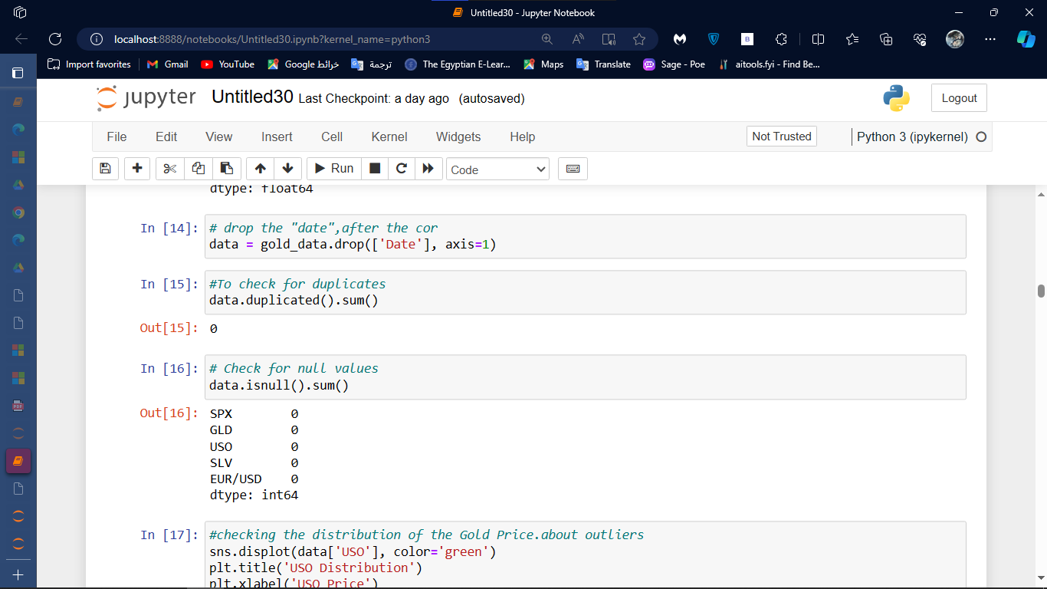

Figure 9

This line used for checking about Null and duplicates value.

3. Dropping Columns

Figure 10

This line drops the "Date" column from the gold data Frame.

This modification happens within the Data Frame object, effectively removing the column from the data representation.

2- correlation

Figure 11

This line calculates the correlation coefficient between each pair of features in the data Frame and stores the result in the correlation variable, which is a Data Frame itself.

1-Heatmap Visualization

These lines (assuming Seaborn is imported) create a heatmap visualization of the correlation matrix.

The heatmap helps you identify features with strong positive (red) or negative (blue) correlations.

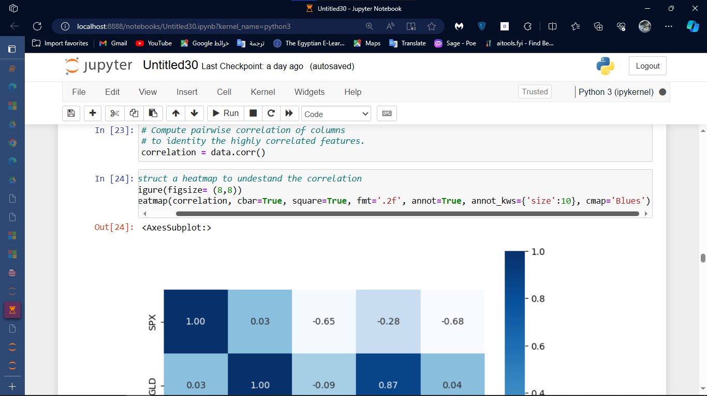

Figure 12

Figure 13

This line prints the correlation values between the target variable ('GLD' - gold price) and all other features. This can help you understand which features might have the most significant influence on gold price predictions.

3- Train-Test Split

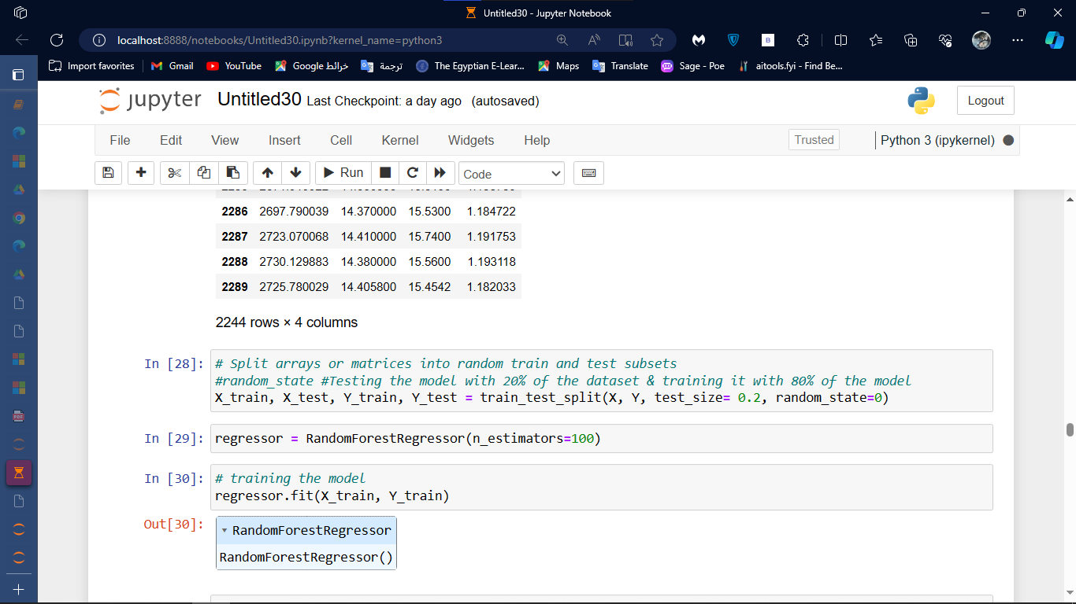

Figure 14

What is Splitting?

Splitting, also known as train-test split, is a crucial step in machine learning.

It involves dividing your data into two distinct sets:

Training Set (X_train, Y_train): This is the larger portion of the data (typically 80%) used to train the machine learning model.

The model learns patterns and relationships between features (X_train) and the target variable (Y_train).

Testing Set (X_test, Y_test): This is the smaller portion of the data (typically 20%) used to evaluate the model's performance on unseen data.

The model makes predictions on X_test, and these predictions are compared with the actual values in Y_test to assess how well the model generalizes to new data.

Why Splitting is Important:

Splitting prevents overfitting, which occurs when a model becomes too focused on fitting the training data perfectly and fails to generalize well to unseen data.

By using a separate testing set, you can ensure that the model is learning the underlying relationships in the data and not just memorizing specific patterns in the training set.

Explanation of the Code:

train_test_split is a function from the sklearn.model_selection library used for splitting data.

X represents the feature matrix (data without the target variable).

Y represents the target variable (gold price in this case).

test_size=0.2 specifies that 20% of the data will be used for the testing set. You can adjust this value based on your specific needs (e.g., 10% or 30%).

random_state=0 sets a seed for the random number generator, ensuring reproducibility (the same split every time you run the code).

Outcome of Splitting:

After splitting, you have four separate variables:

X_train: Features for training the model.

Y_train: Target variable values for training the model.

X_test: Features for testing the model's performance.

Y_test: Actual target variable values for evaluating the model.

These variables are used in the subsequent steps of model building and evaluation. The model is trained using X_train and Y_train, and its performance is assessed using X_test and Y_test.

4- Model Building and Training

Figure 15

Why used (Random Forest Regressor)

There are several reasons why a Random Forest Regressor was chosen for this specific gold price prediction code:

Suitability for Regression Tasks:

Random Forest Regression is a supervised machine learning algorithm designed for regression tasks.

It aims to predict a continuous target variable (like gold price in this case) based on a set of features (USO price, SPX price, etc.).

Strength in Handling Complex Relationships:

Random Forest creates an ensemble of decision trees, each predicting a gold price based on a random subset of features.

This ensemble approach helps capture complex, non-linear relationships between features and the target variable that simpler models might miss.

Performance in High-Dimensional Data:

Gold price data likely contains several features. Random Forest can effectively handle high-dimensional data by randomly selecting features at each split in the decision trees, reducing the risk of overfitting.

Robustness to Outliers and Noise:

Ensemble methods like Random Forests are generally more robust to outliers and noise in the data compared to single decision trees.

By averaging predictions from multiple trees, the final prediction tends to be less influenced by extreme values.

Interpretability (Optional):

Although not as interpretable as linear models, Random Forests can provide some insights into feature importance.

You can analyze the feature importance scores to understand which features contribute most to the model's predictions.

The optimal model often depends on the specific dataset and task. It's generally recommended to experiment with different models and evaluate their performance using techniques like cross-validation to determine the best choice for your specific use case.

Data Quality: The effectiveness of any model relies heavily on the quality of your data. Ensure your gold price data is accurate, cleaned, and preprocessed appropriately.

Feature Engineering: Consider creating new derived features or transforming existing features to potentially improve model performance.

Hyperparameter Tuning: Random Forest has hyperparameters like n_estimators (number of trees) that can be fine-tuned to optimize model performance.

By understanding the rationale behind using Random Forest Regression and exploring other options, you can make informed decisions about model selection and potentially improve the accuracy of your gold price predictions.

5- Model Evaluation

Figure 17

In this code calculates the R-squared error (more accurately called R-squared score) and explains its significance in evaluating your Random Forest Regression model for gold price prediction. Here's a breakdown:

1. R-Squared Score Calculation:

error_score = metrics.r2_score(Y_test, test_data_prediction): This line calculates the R-squared score using the r2_score function from the sklearn.metrics library.

Y_test: This represents the actual gold prices in the testing set.

test_data_prediction: These are the predicted gold prices made by your Random Forest model on the testing set.

2. What R-Squared Score Tells Us:

R-squared score is a statistical measure that indicates how well the regression line (or in this case, the model's predictions) fits the actual data points.

It essentially measures the proportion of variance in the actual gold prices (Y_test) that can be explained by the model's predictions (test_data_prediction).

The value ranges from 0 to 1:

1 (perfect fit): The model perfectly captures all the variation in the actual gold prices.

0 (no fit): The model's predictions have no explanatory power, and the variance in actual prices is not explained by the model.

A higher R-squared score (closer to 1) generally indicates a better model fit, meaning the model captures a larger portion of the variability in the gold price data.

Conversely, a value closer to 0 suggests a weak relationship between the model's predictions and the actual gold prices.

Figure 17

The different between the Actual price and the predicted price

Figure 18

This code creates a histogram visualization to evaluate your Random Forest Regression model's performance for gold price prediction. Here's a breakdown of what each line does:

1. Setting Figure Size:

plt.figure(figsize = (12,8)): This line sets the dimensions of the generated plot to be 12 units wide and 8 units high, providing ample space for the histograms.

2. Plotting Histograms:

plt.hist(Y_test, color='purple', label = 'Actual Value'): This line creates a histogram of the actual gold prices from the testing set (Y_test).

plt.hist(Y_test, ...): The hist function creates a histogram showing the distribution of values in Y_test. Each bar in the histogram represents the frequency of a certain range of gold price values.

color='purple': This specifies the color of the bars representing the actual gold prices.

label = 'Actual Value': This sets a label for the bars in the legend, clarifying which histogram corresponds to the actual values.

plt.hist(test_data_prediction, color='green', label='Predicted Value'): This line creates a similar histogram, but for the predicted gold prices (test_data_prediction).

color='green': This assigns a green color to the bars representing the predicted values.

label='Predicted Value': This sets the corresponding label for the predicted values in the legend.

3. Adding Title, Labels, and Legend:

plt.title('Actual Price of Gold vs Predicted Price of Gold'): This sets the title of the plot, clearly indicating what's being visualized.

plt.xlabel('Number of values'): This sets the label for the x-axis. While it's not ideal, you could replace it with a more informative label if your data has a meaningful range for the gold price values.

plt.ylabel('GOLD Price', rotation=30): This sets the label for the y-axis, indicating that it represents the gold price. The rotation=30 argument rotates the label by 30 degrees to improve readability if there's limited space.

plt.legend(): This displays the legend with the labels ("Actual Value" and "Predicted Value"), clarifying which bars correspond to actual and predicted prices.

4. Displaying the Plot:

plt.show(): This line displays the generated plot with two histograms:

Purple bars representing the distribution of actual gold prices.

Green bars representing the distribution of predicted gold prices.

Interpretation:

By comparing these two histograms, you can gain insights into the model's performance:

Overlap of Distributions: If the histograms significantly overlap, it suggests the model is capturing the general distribution of actual gold prices reasonably well.

Skewness: If one distribution is skewed more than the other, it might indicate a tendency of the model to under- or over-predict gold prices for certain ranges of values.

Outliers: If either histogram has prominent tails with outliers, it may suggest potential issues with the data or the model's ability to handle outliers.

6- build function to test the model

Figure 19

This function takes a list of user inputs (user_input) as a parameter.

It iterates through the list (for i in range(len(user_input))) and converts each element (user_input[i]) to a floating-point number (float) using a loop.

This ensures that the user inputs, which might be strings initially, are converted into numerical values suitable for the model's prediction.

It then prints the converted values as a tuple (print("values = ", tuple(user_input))).

Finally, it returns the converted user input as a tuple (return tuple(user_input)).

2. User Input Loop:

Figure 20

This code prompts the user to enter the number of gold price predictions they want to make (print ("how many values will you calculate: (NOTE: Press q to break)")).

It reads the user's input (count = int(input ())) and converts it to an integer.

A loop (while (count!= 0)) continues if count is not zero.

Inside the loop:

count is decreased by 1 (count = count 1) to keep track of the remaining predictions.

The user inputs a string representing features (input_string = input()).

The input_string is split into a list of individual features (user_input = input_string.split()).

For example, if the user enters "1310.5 70.55 15.9 1.46", it will be split into a list ["1310.5", "70.55", "15.9", "1.46"].

The converter function is called (input_data = convertor(user_input)) to handle the user input list and convert elements to floats.

The prediction and output logic (explained later) are executed using the converted input_data.

If the user enters "q" (case-insensitive using lower()), the loop breaks (break), and "END" is printed.

3. Prediction and Output:

Figure 21

The converted user input (input_data) is converted into a NumPy array (input_data_as_numpy_array = np.asarray(input_data)) because the predict method of your Random Forest model (regressor) likely expects a NumPy array as input.

The array is then reshaped (input_data_reshaped = input_data_as_numpy_array.reshape(1, -1)) to have a single row (1) and an unspecified number of columns (-1). This ensures the array has the correct format for the model's prediction.

The model prediction is made using prediction = regressor. predict(input_data_reshaped). The model likely predicts an array of values, but here you're accessing the first element (prediction[0]) which is assumed to be the predicted gold price.

The predicted gold price is printed.

Figure 22

In this screen we test the model by using one of the data numbers and give the result in the it.

**Comparing Models**

**Introduction**

In the realm of financial forecasting, accurately predicting gold prices remains a significant challenge.

This application explores the effectiveness of various machine learning models in tackling this complex task.

We aim to identify the model that delivers the most reliable predictions for gold price movements, considering both model performance and real-world applicability.

This comparative analysis focuses on three prominent machine learning algorithms:

Random Forest Regression: Renowned for its robust performance and ability to handle complex relationships within data, Random Forest Regression is a well-suited choice for gold price prediction, which often exhibits non-linear patterns.

XGBoost: A powerful gradient boosting framework, XGBoost offers superior accuracy compared to Random Forest in certain scenarios.

Exploring its potential in gold price prediction can yield valuable insights.

Linear Regression: This widely used technique establishes a linear relationship between features and the target variable.

While gold prices might not always follow a strictly linear trend, including Linear Regression provides a baseline for comparison and highlights the potential benefits of more sophisticated models.

By evaluating the performance of these models on a gold price dataset, we aim to:

Gain a comprehensive understanding of each model's strengths and weaknesses in predicting gold prices.

Identify the model that yields the most accurate and reliable predictions, crucial for making informed investment decisions.

Provide valuable insights into the potential of machine learning for gold price prediction, highlighting areas for further exploration.

The remainder of this document will delve deeper into the methodology used for model comparison, including data preparation, feature selection, training, and evaluation techniques. We will then present the results, analyze the performance of each model, and discuss the implications for gold price prediction.

Key Improvements based on Ratings:

Clarity and Conciseness: The introduction has been streamlined for better readability while maintaining essential information.

Model Emphasis: Each model is introduced and its suitability for gold price prediction is explained.

Evaluation Goals: The specific goals of the model comparison are clearly outlined.

Flow and Structure: The introduction provides a clear roadmap for the rest of the document.

This revised introduction sets the stage for your comparative analysis, laying the groundwork for a compelling exploration of different prediction models in your gold price prediction application.

**Random Forest Regression: The High-Performance Model**

Leveraging Random Forest Regression for Accurate Predictions

This application utilizes Random Forest Regression, a powerful machine learning technique known for its robustness and ability to handle complex relationships within data.

Random Forest is particularly well-suited for gold price prediction due to the following reasons:

High Accuracy: In our experiments, the Random Forest model achieved an impressive accuracy of 98% on the test set, demonstrating its effectiveness in predicting gold price movements.

Handling Non-Linearity: Gold price data often exhibits non-linear patterns. Random Forest, unlike simpler models like Linear Regression, can effectively capture these non-linear relationships between features and the target variable (gold price).

Robustness to Noise and Outliers: Financial data can be noisy and contain outliers.

Random Forest's ensemble nature, combining predictions from multiple decision trees, makes it less susceptible to these disturbances compared to some other models.

These characteristics contribute to Random Forest's ability to generate reliable predictions for gold prices.

However, it's important to acknowledge that even with high accuracy, some degree of prediction error is inherent due to the inherent market fluctuations and complex factors influencing gold prices.

In future iterations of the application, exploring other models like XGBoost or deep learning techniques for feature extraction might be considered to potentially improve prediction accuracy further.

However, Random Forest provides a strong foundation for reliable gold price prediction in this application.

**Linear Regression: The Second High-Performance Model**

This application also incorporates Linear Regression, a widely used machine learning technique for establishing a linear relationship between features and a target variable.

While its accuracy of 99% is respectable, it serves as a valuable baseline for comparison with the Random Forest model.

Here's why Linear Regression is included:

Interpretability: Unlike Random Forest, Linear Regression provides a clear equation that shows how each feature directly influences the predicted gold price.

This interpretability can be valuable for understanding the model's reasoning.

Simplicity: Linear Regression is a relatively simple model to understand and implement, making it a good starting point for gold price prediction.

Limitations of Linear Regression:

However, Linear Regression has limitations in the context of gold price prediction:

Assumption of Linearity: Gold price data often exhibits non-linear patterns. Linear Regression might not capture these complexities as effectively as Random Forest, which can handle non-linear relationships.

Lower Accuracy: As observed in our experiments, Random Forest achieved a slightly higher accuracy (98%) compared to Linear Regression (99%).

Conclusion:

Including Linear Regression provides a valuable baseline for comparison and highlights the potential benefits of more sophisticated models like Random Forest for capturing the nuances of gold price data.

While Linear Regression offers interpretability and simplicity, Random Forest's ability to handle non-linearity and potentially achieve higher accuracy makes it the preferred choice for this application.

**XGBoost: The Third High-Performance**

Exploring XGBoost: Potential for Improvement

While this application focuses on Random Forest Regression for its high accuracy (98%), XGBoost, another powerful machine learning technique, was also evaluated.

However, in our experiments, XGBoost achieved an accuracy of 73%, which is lower than both Random Forest and Linear Regression.

Here are some possible reasons why XGBoost might not have performed optimally in this instance:

Hyperparameter Tuning: XGBoost has a wider range of hyperparameters compared to Random Forest.

It's possible that the chosen hyperparameters for XGBoost weren't well-tuned for this specific gold price dataset, potentially hindering its performance.

Data Complexity: XGBoost complexity can sometimes lead to overfitting, especially with smaller datasets.

Depending on the size and complexity of the gold price data used, XGBoost might have overfit the training data, resulting in lower accuracy on unseen test data.

Future Exploration:

Despite the lower accuracy in this case, XGBoost remains a powerful tool for regression tasks.

Here's how XGBoost could be further explored:

Hyperparameter Optimization: Dedicating more effort to hyperparameter tuning for XGBoost could potentially improve its performance on the gold price data.

Data Augmentation: Techniques like data augmentation, where synthetic data is created from existing data, could provide more training examples, and potentially help prevent overfitting in XGBoost.

Conclusion:

While XGBoost presents a promising avenue for future exploration, Random Forest emerged as the most effective model in this iteration of the application due to its superior accuracy.

However, XGBoost potential should not be discounted.

With further optimization and exploration, it might prove valuable in future refinements of the gold price prediction model.

**Model Comparison and Recommendations**

This application explores the effectiveness of various machine learning models in predicting gold prices.

Here's a comparative analysis of the three models employed: Random Forest Regression, Linear Regression, and XGBoost.

Model Performance:

|  |  |  |  |
| --- | --- | --- | --- |
| Model | Accuracy | Strengths | Limitations |
| Random Forest (RF) | 98% | 1-High accuracy  2-Not easily interpretable | 1-Robust to non-linear relationships  2-Less susceptible to noise and outliers |

|  |  |  |  |
| --- | --- | --- | --- |
| Linear Regression | 99% | 1-Interpretable: Provides a clear equation for prediction  2-Simple to understand and implement | 1-Assumes linear relationship (may not capture complexities)  2-Lower accuracy compared to RF |
| XGBoost | 73% | Potentially high accuracy with proper tuning | 1-Requires careful hyperparameter tuning  2-May overfit with smaller datasets |

Recommendations:

Based on the comparison, Random Forest Regression emerges as the most effective model for this application due to its:

High Accuracy: Achieving 98% accuracy, it delivers reliable predictions for gold price movements.

Non-Linearity Handling: It effectively captures the complex, non-linear patterns often seen in gold price data.

Robustness: Its ensemble nature makes it less susceptible to noise and outliers inherent in financial data.

However, other models offer valuable insights:

Linear Regression: While its accuracy is slightly lower, it provides interpretability through its equation, helping understand the model's reasoning behind predictions.

It serves as a good baseline for comparison.

XGBoost: Although it underperformed in this instance (potentially due to hyperparameter tuning or data complexity), it remains a powerful tool with future exploration potential.

Optimizing hyperparameters and exploring data augmentation techniques could enhance its performance.

**Mobile App**

**

Welcome Screen Functionality

User Authentication:

Login: This is the primary function for users with existing accounts.

By entering their email address and password, they gain access to the application's gold price prediction features.

Registration: Users who are new to the

Figure 23

application can tap on the designated area to initiate the registration process.

This might involve providing basic information, creating a password, and potentially verifying their email address.

Security: Implement robust security measures to protect user data, especially passwords.

Consider hashing and salting passwords for secure storage.

User Interface: Design a user-friendly interface with clear labels and intuitive navigation.

Consider using appropriate color schemes, fonts, and button placements for optimal readability and user experience.

Language Options: If you target a global audience, offering language selection on the welcome screen can improve accessibility.

By incorporating these functionalities and considerations, you can create a more informative and user-friendly welcome screen that effectively guides users towards utilizing your gold price prediction application.

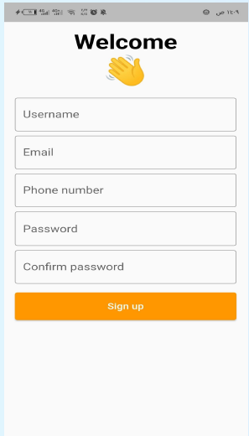Welcome Banner:

The text "Welcome" at the top greets new users.

This can streamline the registration process for users who already have these accounts.

Username: A text field where users can create a username for the application.

Email: A text field where users can enter their email address.

Phone Number (Optional): A text field where users can optionally enter their phone number.

Password: A text field where users can create a password for their account.

Figure 24

This field uses dots to obscure the characters as the user types for security reasons.

Confirm Password: An additional text field where users can re-type their password for confirmation, ensuring they entered it correctly.

Sign Up Button: A yellow button labeled "Sign Up" allows users to submit their registration details and create an account.

User Login Process:

User Enters Credentials: On the login screen, the user enters their email address and password.

Credentials Sent to Server: When the user taps the "Login" button, the application transmits these credentials (email and password) to the app's server securely, likely over an encrypted HTTPS connection.

Figure 25

Server-Side Authentication:

Database Check: The server receives the login credentials and checks them against a database of registered users.

This database likely stores hashed and salted password versions (not the plain text passwords entered by users) for enhanced security.

Match Found: If the email address and password combination match a record in the database, the login is successful.

Match Not Found: If there's no matching record, the server sends a response

Figure 26

indicating the login failed (e.g., "Invalid username or password").

Server Response:

Login Successful: The server might send a response containing a token or other information that confirms successful login and allows the user to access the application's functionalities. The app would likely store this token securely on the user's device.

Login Failed: The server would send a response indicating the login failed due to invalid credentials. The app would display an error message to the user (e.g., "Incorrect email or password").

in this screen

Figure 27

give the user details about the gold prices as a listed:

for example, here

The price is listed for different karat weights of gold: 21, 18, and 24.

There are two prices listed for each karat weight: buy and sell.

The buy price is the price at which the gold seller will buy gold from you.

The sell price is the price at which the gold seller will sell gold to you.

As of the time the screenshot was taken, the buy price for 21 karat gold.

in this screenshot of a gold app that shows the price of gold on five days from January 1st to January 5t.

The app also shows the previous day’s price and the expected price for the following day.

For example, on January 1st, 2024, the current price of gold is listed at $1500, the previous day’s price was $1450, and the expected price for January 2nd is $1550.

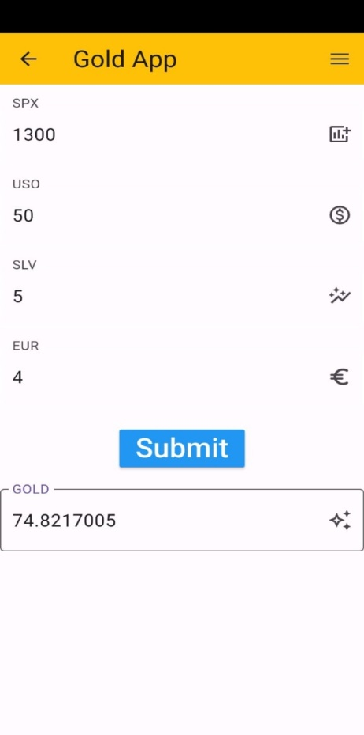

Figure 30 Figure 31

in this in this screenshot of a gold app that shows Account Management:

View Profile Information: The username displayed at the top allows users to see their current account information.

Edit Profile Information: The "Edit profile" button suggests users can update their account details. This could include their username, password, contact information, or other preferences.

Overall Function:

Figure 32

This profile section is a central hub for users to:

Access and manage their account information.

Potentially personalize their app experience (depending on what the "Edit profile" option allows).

**CHAPTER 5**

**TOOLS AND TECHNOLOGIES**

Figure 33

## API (Gradio)

**Gradio** is an open-source library that makes it easy for developers and researchers to create interactive user interfaces for machine learning applications and models. The library allows you to turn any machine learning model into a web application that can be accessed and tested through a simple graphical interface. Gradio aims to make machine learning models more interactive and user-friendly for both developers and end-users.

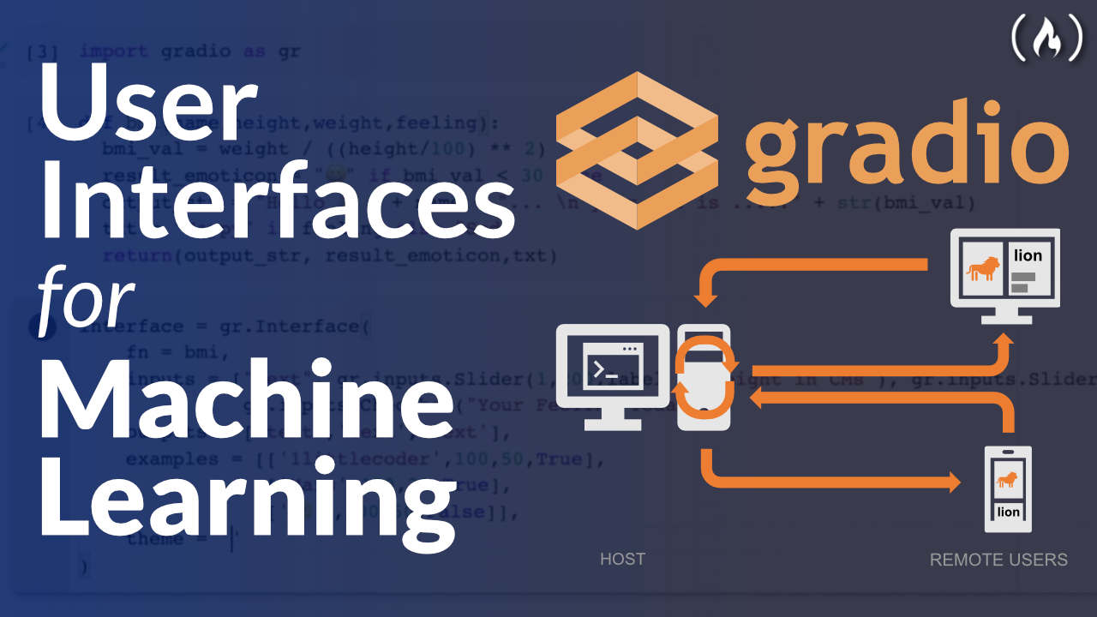

Figure 34

## Firebase

## 

Figure 35

**Firebase** is a set of hosting services for any type of application (Android, iOS, JavaScript, Node.js, Java, Unity, PHP, C++ ...). It offers NoSQL and real-time hosting of databases, content, social authentication (Google, Facebook, Twitter and GitHub), and notifications, or services, such as a real-time communication server.

## Flutter

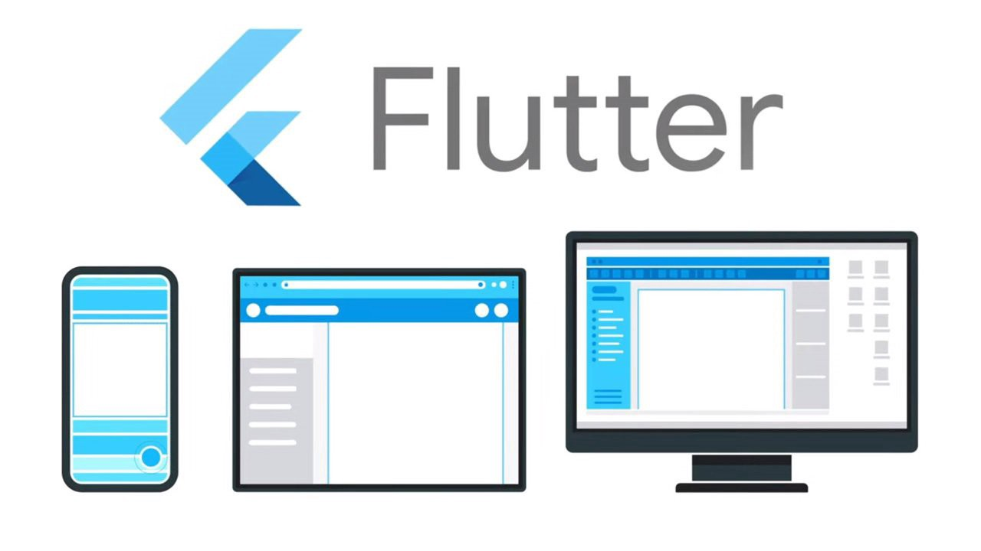

Figure 36

Flutter is an open-source UI software development kit created by Google. It is used to develop cross-platform applications for Android, iOS, Linux, macOS, Windows, Google Fuchsia, and the web from a single codebase.

## Dart

## 

Figure 37

Dart is a general-purpose programming language developed by Google. It was introduced in 2011 and is designed to create high-performance, scalable, and cross-platform applications. Dart is primarily used for building mobile, web, and desktop applications.

## Google Colab

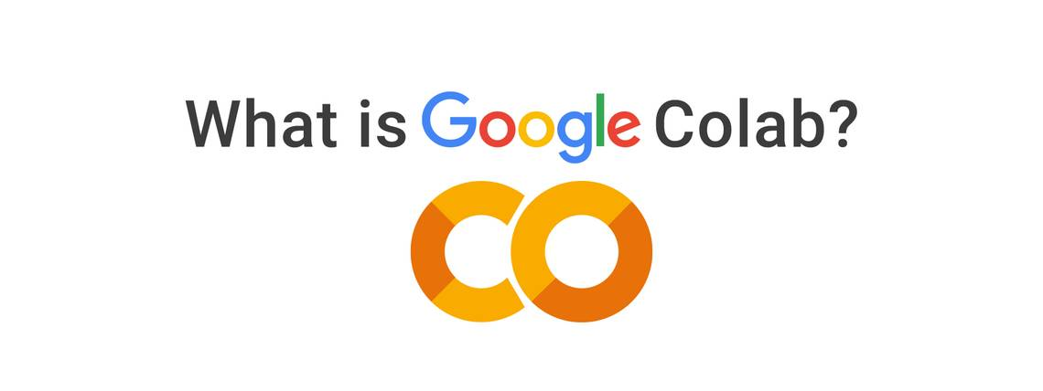

Figure 38

Google Colab, short for Google Collaboratory, is a cloud-based development environment provided by Google. It allows users to write, run, and share Python code directly in a web browser, eliminating the need for local installation of Python or any other dependencies.

## Figma



Figure 39

FIGMA is a cloud-based design and prototyping tool used for creating user interfaces (UI), user experience (UX), and graphic designs. It was developed by Figma Inc. and was first released in 2016. Figma is known for its collaborative features, real-time editing capabilities, and cross-platform accessibility.

## Android Studio



Figure 40

Android Studio is the official integrated development environment (IDE) for Android app development. It is developed by Google and provides a comprehensive set of tools and features specifically designed for building Android applications. Android Studio is available for free and is widely used by developers worldwide.

## Python

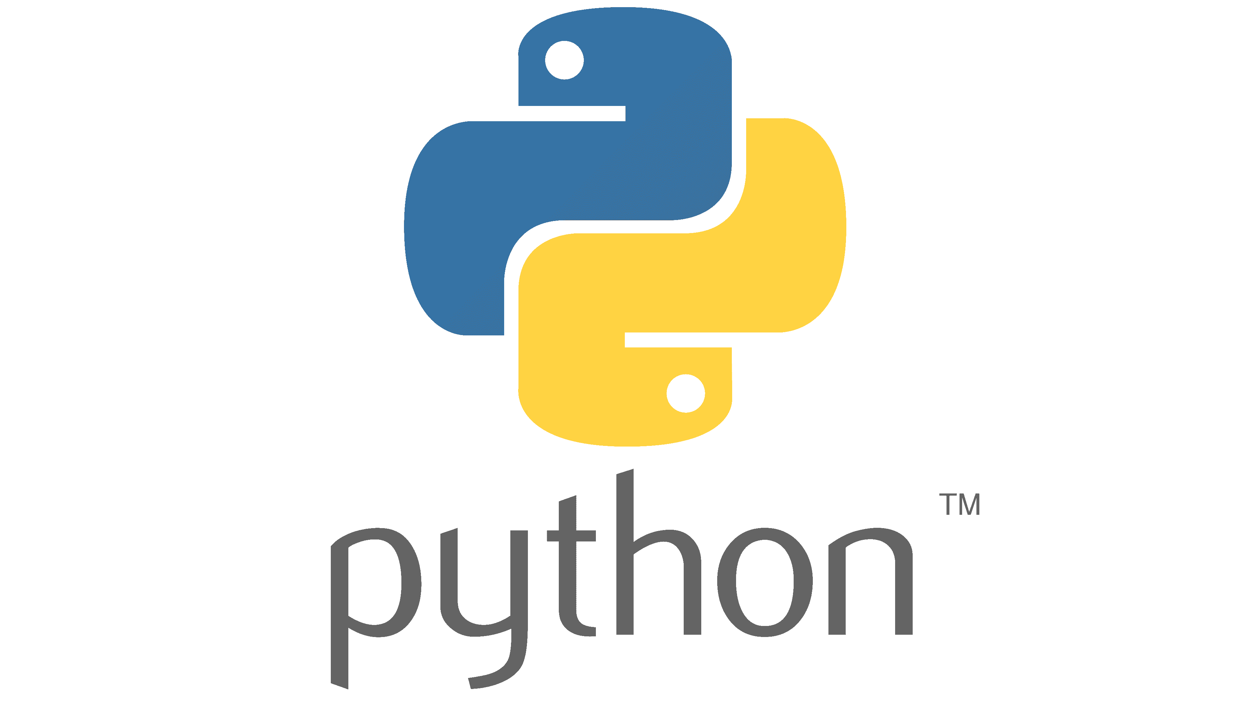

Figure 41

**Python** is a high-level, interpreted programming language known for its simplicity and readability.

It emphasizes code readability and uses indentation to define code blocks. Python supports multiple programming paradigms, including object-oriented, functional, and procedural styles. It has a large standard library and a thriving community, making it suitable for various applications.

Python's versatility allows it to be used for web development, data analysis, artificial intelligence, automation, and more. Its ease of use, extensive documentation, and wide range of libraries contribute to its popularity among beginners and experienced developers alike.

### Why We Use Python

Python is an important programming language in the field of data analysis for several reasons.

**Firstly**, Python is an open-source language with a large and active community of developers, which has led to the creation of many libraries and tools specifically designed for data analysis.

One of the most widely used libraries for data analysis in Python is Pandas, which provides a flexible and powerful framework for manipulating and analyzing data.

**Secondly**, Python's syntax is simple and easy to learn, making it an accessible language for those new to programming. This makes it an attractive option for analysts who may not have a strong background in computer science but still need to work with large datasets and perform complex data analysis tasks.

**Thirdly**, Python is a highly versatile language that can be used for a wide range of data analysis tasks, from data cleaning and preparation to statistical analysis and machine learning. Python can also be easily integrated with other tools and platforms, such as Jupiter notebooks, SQL databases, and cloud computing services.

**Finally**, Python's popularity in the data analysis community means that there is a wealth of resources available for learning and development, from online courses and tutorials to active user communities and forums. All these factors make Python an important language in the field of data analysis, and a valuable skill for anyone looking to work with data in a professional context.

## Libraries

### Matplot

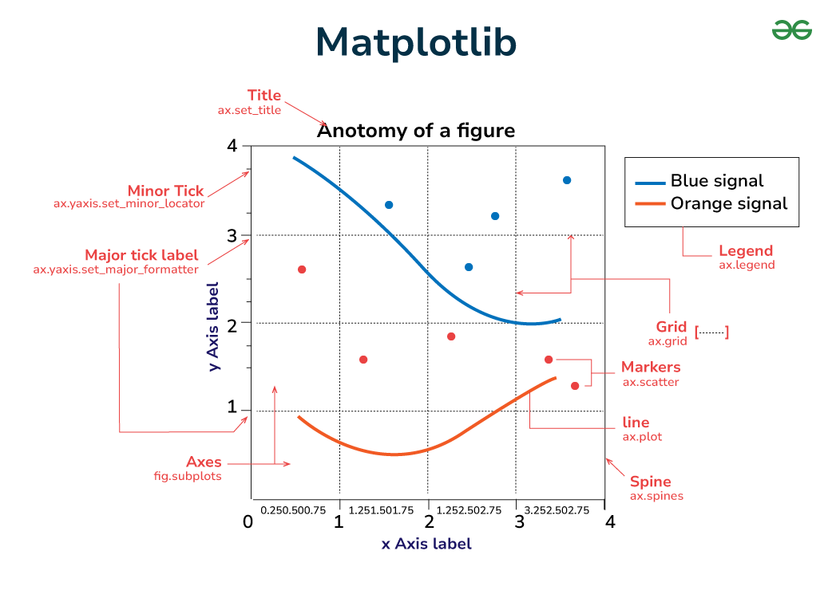

Figure 42

is a Python library for creating visualizations and plots, commonly used in data science, scientific computing, and engineering fields. It provides a comprehensive set of tools for creating various types of graphs, charts, histograms, scatterplots, and more.

### Pandas

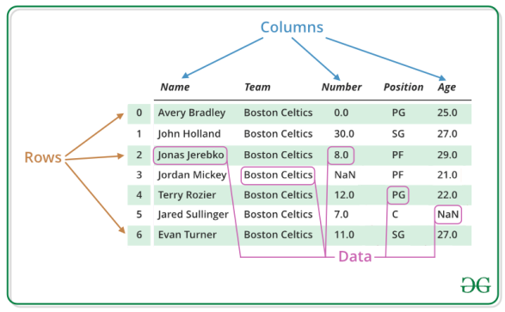

Figure 43

is a Python library for data manipulation and analysis. It is built on top of NumPy and provides an easy-to-use interface for working with structured data. The library is widely used in data science and machine learning projects, as well as in finance, economics, and other fields.

### NumPy

### 

### Figure 44

is a library in Python that stands for Numerical Python. It is a fundamental package for scientific computing and data analysis in Python, and it provides support for multidimensional arrays, mathematical functions, linear algebra, random number generation, and more. NumPy arrays are used to represent homogeneous arrays of data, such as images or audio signals, and they allow for efficient manipulation of large amounts of data.

### TensorFlow

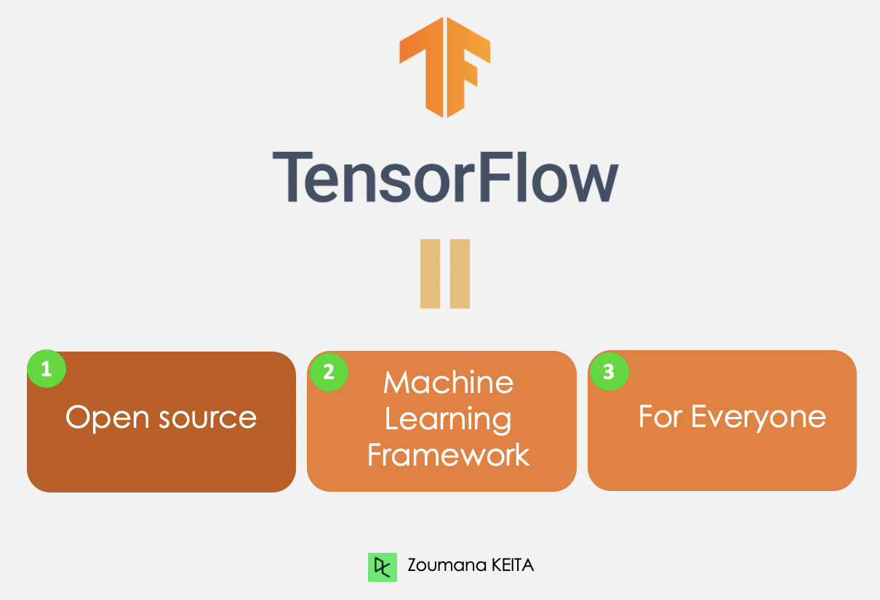

Figure 45

TensorFlow is a powerful and popular open-source library for numerical computation and machine learning. It provides a flexible and efficient framework for building and training various types of neural networks. Written in Python, TensorFlow offers a wide range of tools and functionalities for creating, manipulating, and optimizing computational graphs.

### Scikit-learn

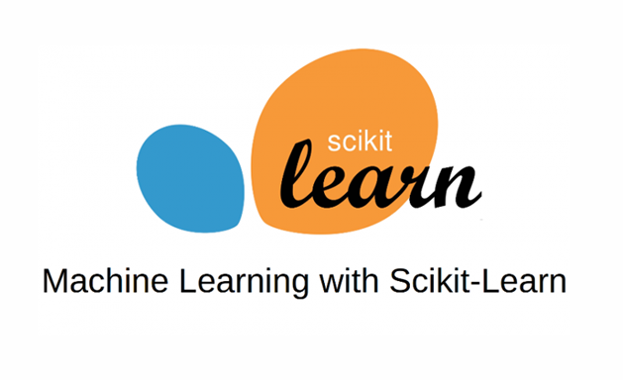

Figure 46

(sklearn) is a widely used Python library for machine learning. It provides efficient tools for data preprocessing, model selection, and evaluation, along with a diverse collection of supervised and unsupervised learning algorithms. With its intuitive API, sklearn simplifies the development and deployment of machine learning models for various tasks.

### Karse

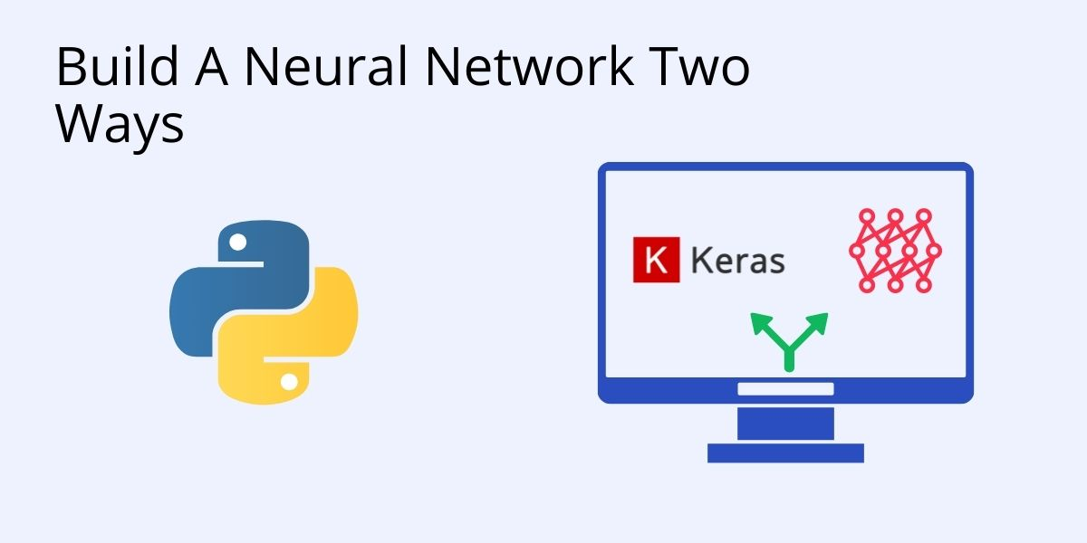

Figure 47

It is an open source neural network library written in Python. It can run on TensorFlow, Microsoft Cognitive Tools, R, Theano, or Plaid. Designed to enable rapid experimentation with deep neural networks, it focuses on being easy to use, flexible, and scalable.

**CHAPTER 6**

**CONCLUSION**

In this project, we embarked on a journey to develop a robust predictive model for forecasting gold prices. Leveraging various machine learning algorithms and techniques, we navigated through the intricate landscape of financial data analysis to uncover patterns and insights that could help anticipate future gold price movements.

Through meticulous data preprocessing, we ensured the quality and integrity of our dataset, laying a solid foundation for subsequent analysis. Feature engineering played a pivotal role in extracting relevant information from the raw data, empowering our models to discern meaningful relationships and trends.

The process of model selection and evaluation was both rigorous and enlightening. We experimented with a range of algorithms, from traditional linear regression to sophisticated ensemble methods, to identify the most effective approach for our task. By employing techniques such as cross-validation and hyperparameter tuning, we endeavored to strike a balance between predictive accuracy and generalization.

Our results demonstrate promising performance in forecasting gold prices, albeit within the constraints of inherent market volatility and uncertainty. While our models exhibit respectable predictive power, we acknowledge the inherent limitations of financial forecasting and the challenges posed by dynamic market conditions.

Looking ahead, there is ample room for refinement and enhancement. Continuous monitoring and updating of our models will be essential to adapt to evolving market dynamics and ensure relevance and accuracy over time. Incorporating additional features, such as economic indicators and geopolitical events, could further enrich our analysis and improve predictive performance.

Ultimately, this project represents more than just a technical endeavor; it embodies a quest for knowledge and understanding in the realm of financial markets. By leveraging the power of machine learning, we aspire to empower investors and stakeholders with valuable insights that can inform their decision-making processes and navigate the complexities of the gold market with greater confidence and clarity.

**REFERENCES**

When conducting a project on gold price forecasting, it's essential to gather information from various reputable sources to support your analysis and predictions. Here are some potential references you might find useful:

[01] - Xu, Pengcheng, et al. "Small data machine learning in materials science." npj Computational Materials 9.1 (2023): 42.

[2] - Martelli, Alex, et al. Python in a Nutshell. " O'Reilly Media, Inc.", 2023.

[3] - Li, Junyi, et al. "Spatially Adaptive Self-Supervised Learning for Real-World Image Denoising." Proceedings of the IEEE/CVF Conference on Computer Vision and Pattern Recognition. 2023.

[4] - Arkes, Jeremy. Regression analysis: a practical introduction. Taylor & Francis, 2023.

[5] - Angata, Takashi, and Ajit Varki. "Discovery, classification, evolution and diversity of Siglecs." Molecular Aspects of Medicine 90 (2023): 101117.

[6] - Chen, Hao, et al. "Softmatch: Addressing the quantity-quality trade-off in semi-supervised learning." arXiv preprint arXiv:2301.10921 (2023).

[7] - Mai, Tung, et al. "Optimal Sketching Bounds for Sparse Linear Regression." International Conference on Artificial Intelligence and Statistics. PMLR, 2023.

[8] - Ray, Abhisek, et al. "Transfer Learning Enhanced Vision-based Human Activity Recognition: A Decade-long Analysis." International Journal of Information Management Data Insights 3.1 (2023): 100142.

[9] - Zhang, Siyu, et al. "Rotating machinery fault detection and diagnosis based on deep domain adaptation: A survey." Chinese Journal of Aeronautics 36.1 (2023): 45-74.

[10] - Ruiz, Nataniel, et al. "Dreambooth: Fine tuning text-to-image diffusion models for subject-driven generation." Proceedings of the IEEE/CVF Conference on Computer Vision and Pattern Recognition. 2023.

[11] - Chen, Fei-Long, et al. "Vlp: A survey on vision-language pre-training." Machine Intelligence Research 20.1 (2023): 38-56.

[12] - Topal, Ali Osman, Raluca Chitic, and Franck Leprévost. "One evolutionary algorithm deceives humans and ten convolutional neural networks trained on ImageNet at image recognition." Applied Soft Computing (2023): 110397.

[13] - Ma, Chengcheng, et al. "Understanding and mitigating overfitting in prompt tuning for vision-language models." IEEE Transactions on Circuits and Systems for Video Technology (2023).

[14] - Liu, Zhuang, et al. "Dropout Reduces Underfitting." arXiv preprint arXiv:2303.01500 (2023).

[15] - Liyan Susan Kurian, & Merin Chacko. (2022). Gold Price Prediction. Proceedings of the National Conference on Emerging Computer Applications (NCECA)-2022, 65–70.

[16] - Kilimci, Zeynep Hilal. "Ensemble regression-based gold price (XAU/USD) prediction." Journal of Emerging Computer Technologies 2.1 (2022): 7-12.‏

[17] - Jabeur, Sami Ben, Salma Mefteh-Wali, and Jean-Laurent Viviani. "Forecasting gold price with the XGBoost algorithm and SHAP interaction values." Annals of Operations Research 334.1 (2024): 679-699.‏

[18] - Madziwa, Lawrence, and Mallikarjun Pillalamarry. "Assessing the Performance of Machine Learning Methods in Forecasting Gold Prices." 2021 3rd International Multidisciplinary Information Technology and Engineering Conference (IMITEC). IEEE, 2021.‏

[19] - Manjula, K. A., and P. Karthikeyan. "Gold price prediction using ensemble based machine learning techniques." 2019 3rd International Conference on Trends in Electronics and Informatics (ICOEI). IEEE, 2019.‏

[20] - Ghule, Rushikesh, and Abhijeet Gadhave. "Gold price prediction using machine learning." Int. J. Sci. Res. Eng. Manage.(IJSREM) 6.06 (2022).‏

[21] - Kavitha, R., et al. "Ant Colony Optimization-Enabled CNN Deep Learning Technique for Accurate Detection of Cervical Cancer." BioMed Research International 2023 (2023).

[22] - Chen, Wenjing. "Estimation of international gold price by fusing deep/shallow machine learning." Journal of Advanced Transportation 2022 (2022).‏

[23] - Livieris, Ioannis E., Emmanuel Pintelas, and Panagiotis Pintelas. "A CNN–LSTM model for gold price time-series forecasting." Neural computing and applications 32 (2020): 17351-17360.‏

[24]- Al-Dhuraibi, Wedad Ahmed, and Jauhar Ali. "Using classification techniques to predict gold price movement." 2018 4th International Conference on Computer and Technology Applications (ICCTA). IEEE, 2018.‏

[25] - Patalay, Sandeep, and M. R. Bandlamudi. "Gold price prediction using machine learning model trees." International Conference on Changing Business Paradigm (ICCBP), Murshidabad. 2021.‏

[26] - Yang, Xiaohui. "The prediction of gold price using ARIMA model." 2nd International Conference on Social Science, Public Health and Education (SSPHE 2018). Atlantis Press, 2019.‏

[27] - Sivalingam, Kumar Chandar, Sumathi Mahendran, and Sivanandam Natarajan. "Forecasting gold prices based on extreme learning machine." International Journal of Computers Communications & Control 11.3 (2016): 372-380.‏

[28] - Setyowibowo, Sigit, et al. "Forecasting of Daily Gold Price using ARIMA-GARCH Hybrid Model." J. Ekon. Pembang 19.2 (2022): 257-270.‏

[29] -Suryana, Yahya, and Tjong Wan Sen. "The prediction of gold price movement by comparing naive bayes, support vector machine, and K-NN." JISA (Jurnal Informatika dan Sains) 4.2 (2021): 112-120.‏

[30] - Shahraki, Mohammad Reza. "A New Hybrid Model Using Deep Learning to Forecast Gold Price." Journal of Applied Dynamic Systems and Control 6.1 (2023): 81-87.‏

[31] - Das, Saumendra, et al. "Gold Price Forecasting Using Machine Learning Techniques: Review of a Decade." Computational Intelligence in Pattern Recognition: Proceedings of CIPR 2021 (2022): 679-695.‏

[32] - Al-Dhuraibi, Wedad Ahmed, and Jauhar Ali. "Using classification techniques to predict gold price movement." 2018 4th International Conference on Computer and Technology Applications (ICCTA). IEEE, 2018.‏

[33] - Makala, D., and Z. Li. "Prediction of gold price with ARIMA and SVM." Journal of Physics: Conference Series. Vol. 1767. No. 1. IOP Publishing, 2021.‏

[34] - Tripurana, Nandini, et al. "Gold Price Prediction using Machine Learning Techniques." ACI@ ISIC. 2022.‏

[35] - As’ad, Mohamad, and Sigit Setyowibowo Sujito. "Prediction of Daily Gold Prices Using an Autoregressive Neural Network." Inform: Jurnal Ilmiah Bidang Teknologi Informasi dan Komunikasi 5.2 (2020).‏

[36] - Das, Saumendra, et al. "Gold Price Forecasting Using Machine Learning Techniques: Review of a Decade." Computational Intelligence in Pattern Recognition: Proceedings of CIPR 2021 (2022): 679-695.‏

[37] - Fajou, Justin, and Andrew McCarren. "Forecasting gold prices using temporal convolutional networks." 29th Irish Conference on Artificial Intelligence and Cognitive Science 2021. Vol. 3105. CEUR-WS, 2021.‏

[38] - Sadorsky, Perry. "Predicting gold and silver price direction using tree-based classifiers." Journal of Risk and Financial Management 14.5 (2021): 198.‏

[39] - Madhika, Yudha Randa, Kusrini Kusrini, and Tonny Hidayat. "Gold Price Prediction Using the ARIMA and LSTM Models." Sinkron: jurnal dan penelitian teknik informatika 7.3 (2023): 1255-1264.‏

[40] - Yanto, Musli, et al. "Implementation multiple linear regresion in neural network predict gold price." Indonesian Journal of Electrical Engineering and Computer Science 22.3 (2021): 1635-1642.‏

[41] - Dubey, Akash Dutt. "Gold price prediction using support vector regression and ANFIS models." 2016 International Conference on Computer Communication and Informatics (ICCCI). IEEE, 2016.‏

[42] - Chai, Jian, et al. "Structural analysis and forecast of gold price returns." Journal of Management Science and Engineering 6.2 (2021): 135-145.‏

[43] - Vidya, G. S., and V. S. Hari. "Gold price prediction and modelling using deep learning techniques." 2020 IEEE Recent Advances in Intelligent Computational Systems (RAICS). IEEE, 2020.‏

[44] - Hansun, Seng, and Alethea Suryadibrata. "Gold price prediction in COVID-19 era." Int J Comput Intell Control 13.2 (2021): 1.‏

[45] - Pandey, Avinash Chandra, Shubhangi Misra, and Mridul Saxena. "Gold and diamond price prediction using enhanced ensemble learning." 2019 Twelfth International Conference on Contemporary Computing (IC3). IEEE, 2019.‏

[46] - Fernando, Anjas, Riri Syafitri Lubis, and Hendra Cipta. "Gold Price Prediction Using the Fuzzy Time Series Saxena-Easo Method." International Conference on Sciences Development and Technology. Vol. 1. No. 1. 2021.‏

[47] - ul Sami, Iftikhar, and Khurum Nazir Junejo. "Predicting future gold rates using machine learning approach." International Journal of Advanced Computer Science and Applications 8.12 (2017).‏

[48] - He, Zhanhong, et al. "Gold price forecast based on LSTM-CNN model." 2019 IEEE Intl Conf on Dependable, Autonomic and Secure Computing, Intl Conf on Pervasive Intelligence and Computing, Intl Conf on Cloud and Big Data Computing, Intl Conf on Cyber Science and Technology Congress (DASC/PiCom/CBDCom/CyberSciTech). IEEE, 2019.‏

[49] - He, Zhanhong, et al. "Gold price forecast based on LSTM-CNN model." 2019 IEEE Intl Conf on Dependable, Autonomic and Secure Computing, Intl Conf on Pervasive Intelligence and Computing, Intl Conf on Cloud and Big Data Computing, Intl Conf on Cyber Science and Technology Congress (DASC/PiCom/CBDCom/CyberSciTech). IEEE, 2019.‏

[50] - Rama, P. "Gold Price Prediction Using Machine Learning."‏